GORDON NEIGHBOURHOOD HOUSE LUNCH MENUS NUTRITIONAL ASSESSMENT

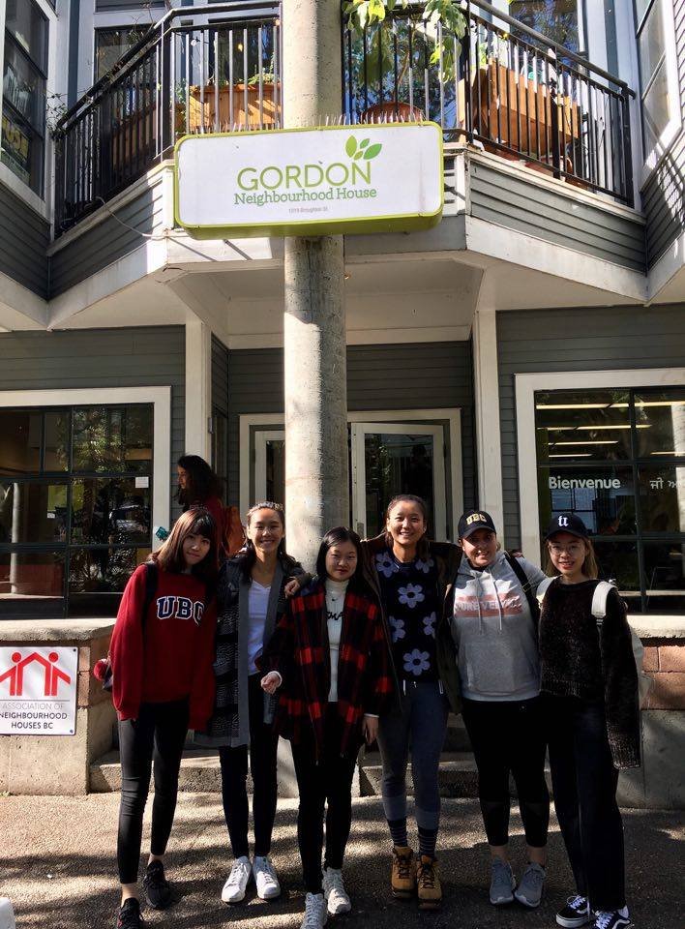
Group 9
11.22.2017
LFS 350

INTRODUCTION
The purpose of this paper is to document our work on promoting nutrition and healthy eating at the Gordon Neighbourhood House (GNH) situated in the West End of Vancouver. Neighbourhood houses have a place-based focus, which reflects and respond to the needs of the community it is located to provide knowledge and resources to support members of the community (Alexandra Neighbourhood House, 2017). In particular, GNH uses food to nourish their community. They nourish the people not just literally but by also facilitating intercultural exchange and dialogue, community capacity-building, and community development (Gordon Neighbourhood House, 2017).
According to one of the GNH coordinators, most people who visit GNH community lunch program are seniors. Seniors have changing nutritional profiles and their body composition changes with age which puts them at a greater risk of deficiency diseases (Lee & Frongillo, 2001). Furthermore, there are studies that show that seniors are not consuming enough nutrients and do not incorporate enough foods from each food group (Roebothan, Friel, and Healey, 1994; Yeung and Imbach, 1988). Therefore, the objectives of our project are to evaluate the nutrient profiles of the foods that are served at GNH and determine whether they meet Canada’s dietary requirements for seniors. Another objective is to create a handout outlining common nutritional deficiencies for seniors and recommendations of common foods addressing these deficiencies.

METHODS
We obtained six recipes from our community partner. The recipes included five from Wednesdays, which are “Pay-What-You-Can” Nourish Bowls, and one “Three-Course Meal” from a Tuesday. The recipes were inputted into EaTracker, a nutrition analysis tool developed by the Dietitians of Canada with the support of the BC Ministry of Health. We averaged the nutrients from all six recipes and compared them to Canada’s Food Guide Recommendation for seniors and the nutritional needs of seniors as per Dietary Reference Intakes Tables by Health Canada. A summary graph of concerns and a list of possible suggestions were collated to determine the nutrients of concern. Since we only had access to lunches, we concluded that the nutrients of concern do not represent nutritional inadequacy in their overall diet but rather nutrients that need to be compensated for in their other two meals.

We familiarized ourselves to GNH by visiting on October 25th, October 31st and November 15th during lunch hours (12 - 1 PM) to record observations of a typical lunch. We performed a qualitative assessment to learn more about the lunch guests upon the request of our community partner. This included a two to three-minute survey with stakeholders during the mealtime in order to gain insight into their thought and suggestions for the lunch program. The following questions were included:
- What is your age?
- Did you enjoy the food?
- What changes would you like to see in future lunches?

Qualitative data was compiled (see Appendix) and general themes were narrowed down in order to highlight key aspects to improve within the lunch program. These data will help cater to the wants and the needs of the guests to maximize their benefits from the nutritional assessment.

RESULTS
Based on our analysis, nine nutrients (vitamin D, calcium, vitamin A, vitamin B6, riboflavin, thiamin, vitamin K, vitamin B12, and folate) were considered limited because they were significantly lower than the Recommended Daily Allowance (RDA) for seniors. Graph 1 highlights the average proportion of each nutrient of concern in the meals at GNH. Vitamin D was at the lowest for both males and females with 0.8% of the RDA met. Analyzation of the individual recipes showing the nutrients of each recipe is located in our appendix.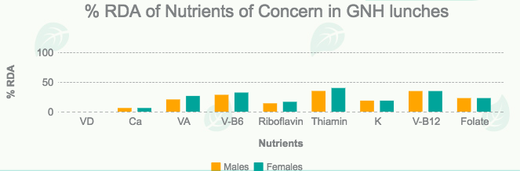
Graph 1: % RDA for nutrients of concern in GNH recipes
On average, the highest contribution in food group serving is Fruits and Vegetables (2.67 servings), followed by Grains (0.95 servings) in each meal. The most lacking food groups are Dairy and Alternatives (0 serving), and Meat and Alternatives (0.3servings), refer to Figure 1 for illustration.
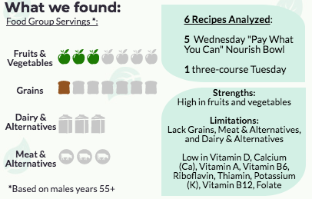
Figure 1: the average proportion of each food group in the recipes at GNH

DISCUSSION
The findings of this study will redound to the benefits of neighborhood houses, particularly GNH, considering that nutritional assessments play an important role in evaluating human health today. Since most of the lunch guests are seniors, the focus of this nutritional assessment of GNH’s lunch menu was targeted towards the aging population. The assessment provided a better overview of the nutritional composition of the meals and we used this information to make plausible and effective suggestions for improvement. In studies examining the adequacy of diet, food intake, and nutrition status in Canadian seniors, it was discovered that all food groups were consumed at levels less than those recommended by Canada’s Food Guide and their nutritional status was far from optimal. It was noted that 33% of participants did not meet the minimum recommendations for Dairy and Alternatives (Roebothan, Friel, and Healey, 1994; Yeung and Imbach, 1988). This was apparent in GNH lunches as well, but meat and alternatives was the food group served in the lowest quantity. This may be due to the high-cost of meat products which does not fit into GNH’s budget.
Seniors experience body compositional changes leading to higher requirements for nutrients for their bodies’ to function properly. While most of the nutrients are relatively adequate, those that are inadequate in our results are also nutrients of concern for seniors. Protein, niacin, riboflavin, vitamin B6 and B12, magnesium, iron, and zinc are some nutrients of concern for seniors since they often consume less than the RDA for these nutrients (Lee & Frongillo, 2001). Other nutrients of concern include vitamin D, calcium, and potassium (HealthLink BC, n.d.) Aggarwal’s research illustrated that nutrients are commonly associated with a lower risk of chronic disease but are related to higher cost diets (diets that consist of relatively more expensive foods, such as beef and salmon)(2012). Many of deficient nutrients are from Dairy and Alternatives and Meat and Alternatives, food groups that are lacking in the recipes. It is important to help reach the nutritional needs of all stakeholders at the lunches regardless of their age, sex, and socioeconomic status. Because the lunches served at GNH are usually low-cost, we need to find ways to ensure that the lunches contain sufficient amounts of all nutrients and food groups with a limited budget. To make that happen, we produced a list of a few common foods that can be introduced or increased in amounts. These foods can help reduce the nutritional gaps found in the recipes; for example tofu, kale, egg, milk, and fortified orange juice (refer to Figure 2 below). Adding a little more dairy, meat, or fortified foods can help prevent deficiencies that are easily acquired by seniors. 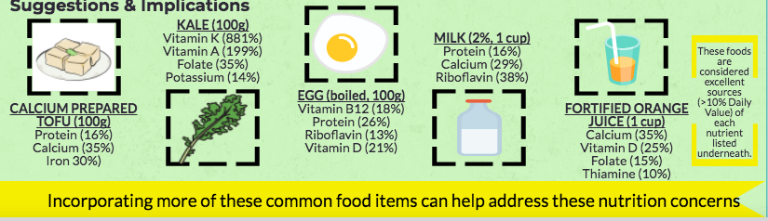
Figure 2: Low-cost suggestions to increase the nutritional content of the meals at GNH
From our qualitative analysis, we can confirm that the majority of lunch guests are seniors. On average, around 20 guests were at each lunch. The main feedback we received was the lunches were amazing and that there is nothing they thought that needed to change, with the exception of incorporating a little more protein, in the form of meat.
LIMITATIONS AND IMPROVEMENTS
One of our limitations involved measuring portion sizes accurately. Some menus provided only had an approximation of what was used instead of the exact amount of the ingredients used in the recipes. Moreover, some of the ingredients were added depending on how much or how little the chef wanted to add. These uncertainties make the process of analysis more difficult (Bradac, 2001). Additionally, produce sizes vary making it difficult for us to accurately convert them into exact portion sizes. Many questions arose while inputting our data, for example, how many cups/grams do three heads of broccoli equate to? Lastly, a small sample of recipes made our results less representative and generalizable. Due to time constraint, we were only able to analyze five of the Wednesday lunch recipes and one Tuesday recipe, which means the results may be skewed. Tuesday and Thursday recipes, which often include more meat, were not well represented.
There are a few ways we could improve our study design for the future. First, we believe that increasing our sample size and incorporating sufficient recipes from different days will allow us to have more accurate data. This will permit us to generalize our data to all the lunches served at GNH. Secondly, we would also like to reduce the uncertainty that occurred in the quantity of food by observing and measuring the ingredients at GNH rather than using the measurements given to us in a recipe.

CONCLUSION

This project has shown that it is important to nutritionally assess community services that provide lunches to their area. As evident in GNH, we found strengths and limitations in the lunches that were provided. Most initiatives and researches largely focus on young adults and children; however, our CBEL project addresses the knowledge gap in nutritional assessments and food security in senior guests that visit neighbourhood houses. Nonetheless, our assessment failed to generalize to all neighbourhood houses and guests due to limited time and lack of provided recipes. Moving forward, nutritional assessments should be conducted on all neighbourhood houses that provide meal services. This will allow the data to become more representative and be used to generate a solution to address unbalanced nutrient distribution.

REFERENCES
Aggarwal, A., Monsivais, P., & Drewnowski, A. (2012). Nutrient Intakes Linked to Better Health Outcomes Are Associated with Higher Diet Costs in the US. PLoS ONE, 7(5).
doi:10.1371/journal.pone.0037533

Alexandra Neighbourhood House. (2017). Settlement Movement - Alexhouse.net
Retrieved October 20, 2017, from
http://www.alexhouse.net/settlement-movement

Bradac, J. (2001). Theory comparison: Uncertainty reduction, problematic integration,
uncertainty management, and other curious constructs. Journal of Communication, 51(3), 456-476. doi:10.1093/joc/51.3.456

Canada, H. (2006). Dietary Reference Intakes. Retrieved November 27, 2017, from
https://www.canada.ca/en/health-canada/services/food-nutrition/healthy-eating/dietary-reference-intakes/tables/reference-values-elements-dietary-reference-intakes-tables-2005.html

Canada, H. (2006). Dietary Reference Intakes. Retrieved November 27, 2017, from
https://www.canada.ca/en/health-canada/services/food-nutrition/healthy-eating/dietary-reference-intakes/tables/reference-values-macronutrients-dietary-reference-intakes-tables-2005.html

Canada, H. (2010). Dietary Reference Intakes. Retrieved November 27, 2017, from
https://www.canada.ca/en/health-canada/services/food-nutrition/healthy-eating/dietary-reference-intakes/tables/reference-values-vitamins-dietary-reference-intakes-tables-2005.html

Gordon Neighbourhood House. (2017). Food Philosophy- GordonHouse.org.
Retrieved September 21, 2017, from
http://gordonhouse.org/about-gordon-neighbourhood-house/right-to-food/

HealthLink BC. (n.d.). Healthy Eating and Healthy Aging for Adults. Retrieved November 27, 2017, from https://www.healthlinkbc.ca/healthlinkbc-files/healthy-eating-adults

Lee, J. S., & Frongillo, E. A. (2001). Nutritional and health consequences are associated with
food insecurity among US elderly persons. The Journal of nutrition, 131(5), 1503-1509.

Roebothan, B. V., Friel, J. K., & Healey, L. (1994). Diet and drug consumption in a group of
elderly residing in rural Newfoundland. Canadian journal of public health= Revue
canadienne de sante publique, 85(5), 313-316.

Yeung, D. L., & Imbach, A. (1988). Geriatric nutrition in Canada-a review. Journal of Nutrition for the Elderly, 7(3), 27-45.

APPENDIX

Food Group | Thai peanut bowl | Polish potato salad | Turmeric Coconut Bowl | Carrot & Chickpea Stew | Tuesday’s Recipe | Middle Eastern Bowl | Average
Grain products | 0.5 | 0 | 2 | 0.5 | 0.4 | 2.3 | 0.95
Fruits and vegetables | 1.5 | 2.2 | 3.5 | 2 | 3.6 | 0.8 | 2.67
dairy and alternatives | 0 | 0 | 0 | 0 | 0 | 0 | 0
Meat and alternatives | 0.5 | 0.8 | 0 | 0.5 | 0 | 0 | 0.3

Nutrient | RDA* | Thai peanut bowl | Polish potato salad | Turmeric Coconut Bowl | Chickpea  Salad | Middle Eastern Bowl | Tuesday’s Recipe | Average
Vitamin A (RAE) | Male: 900  Female: 700 | 200.1 | 164.9 | 513.2 | 188.1 | 34.3 | 6.5 | 185.52  Male: 20.61%  Female: 26.5%
Vitamin C (mg) | Male: 90  Female: 75 | 47.3 | 46.2 | 96.3 | 27.7 | 10.3 | 40.0 | 44.63  M: 49.59%  F: 59.51%
Vitamin D (ug) | Male: 20  Female: 20 | 0.0 | 0.1 | 0.0 | 0.0 | 0 | 0.0 | 0.0167  M/F: 0.08%
Vitamin E (ug) | Male: 15  Female: 15 | 3.5 | 3.5 | 13.8 | 1.2 | 1.7 | 2.4 | 4.35  M/F: 29%
Thiamin (mg) | Male: 1.2  Female: 1.1 | 0.2 | 0.4 | 0.4 | 0.1 | 0.1 | 0.3 | 0.25  M: 20.83%  F: 22.73%
Riboflavin (mg) | Male: 1.3  Female: 1.1 | 0.1 | 0.2 | 0.3 | 0.2 | 0.1 | 0.2 | 0.183  M: 14.08%  F: 16.64%
Niacin (NE) | Male: 16  Female: 14 | 5.2 | 6.3 | 7.2 | 3.3 | 4.7 | 6.8 | 5.583  M: 34.89%  F:39.88%
Folate (DFE) | Male: 400  Female:400 | 82.1 | 59.8 | 152.4 | 115.5 | 20.7 | 118.0 | 91.42  M/F: 22.86%
Vitamin B6 | Male: 1.7  Female: 1.5 | 0.4 | 0.6 | 0.7 | 0.3 | 0.2 | 0.7 | 0.483  M: 28.41%  F: 32.2%
Vitamin B12 (ug) | Male: 2.4  Female: 2.4 | 0.0 | 0.3 | 0.1 | 0.1 | 0 | 0.0 | 0.833  M/F: 34.71%
Calcium (mg) | Male: 1200  Female: 1200 | 52.8 | 39.1 | 184.4 | 89.3 | 32.8 | 47.4 | 74.3  M/F: 6.19%
Iron (mg) | Male: 8  Female: 8 | 2.0 | 1.9 | 6.0 | 2.3 | 1.7 | 3.0 | 2.82  M/F: 35.25%
Fat (g) | Male: ND  Female: ND | 19.2 | 7.7 | 47.2 | 4.4 | 0.9 | 15.2 | 31.53
Protein (g) | Male: 56  Female: 46 | 8.3 | 15.7 | 16.1 | 8.8 | 8.9 | 8.8 | 11.1
Carbohydrate (g) | Male: 130  Female:130 | 29.3 | 35.2 | 60.7 | 36.2 | 51.5 | 67.4 | 46.72
Sodium (mg) (AI) | Male: 1200  Female: 1200 | 401.5 | 709.7 | 1334.8 | 104.4 | 135.7 | 151.8 | 472.98
Potassium (mg) (AI) | Male: 4700  Female:  4700 | 487.8 | 778.9 | 1416.1 | 500.5 | 446.4 | 1609.0 | 873.12  M/F: 18.58%
*results obtained from the Government of Canada
Nutrients highlighted in red: less than ⅓ of RDA

Observations:
Nov 6th
- Inspired vegan hot dish (not very informative of what’s in the dish)
- Suggestion from some people: not everyone is aware that a menu is posted/ not very eye catching
- Self serve tea and coffee (unlimited)
- Mostly Caucasian
- Majority senior but a lot of adults aged 20-49
- 21 guests in total

Age:36
Sex: Male
Comments: no changes, lunch is great

Age: 30
Sex: Male
Comments: Love the lunches

Age: 25
Sex: Female
Comments: has lactose intolerance, sometimes don’t know what’s in the lunch and I can’t eat it because of the dairy

Age: 34
Sex: Female
Comments: first time coming to GNH but the lunch is good

Age: 78
Sex: Female
Comments: portion size was good

Age: 63
Sex: Female
Comments: Enjoyed the lunches

Age: 76
Sex: Male
Comments: Lunch was good, but wants more protein (ex. meat, eggs)

Age: N/A
Sex: Female
Comments: soup was too salty and food could be served hotter

Age: 88
Sex: Female
Comments: come for lunches 2-3 times/week, love the lunches

Nov. 25th
- Nourish bowl with chicken
- Majority seniors: ages 50-80
- Mostly Caucasian and Asian
- Unlimited coffee and tea (self-serve)

Age: N/A
Sex: Female
Comments: food was delicious, “best food in town,”

Age:67
Sex: Male
Comments: bland, no protein

Age:78
Sex: Female
Comments: likes sandwiches and soup, “please bring them back”

CRITICAL REFLECTIONS
STUDENT 1
Over the course of the semester, my thoughts on Food Justice has altered substantially. Initially, I thought of Food Justice as simply the right for people to consume the necessary amount of food to live a healthy lifestyle. Truthfully, I was not sure what it exactly was and how it related to me and others in the world. Working with Gordon Neighbourhood House as well as going to tutorials and lectures has helped me learn more about it; rather than focusing solely on food and helping people get sufficient amounts of food, Food Justice should focus on an asset-based approach as well. An asset-based approach is when a community uses what they have to grow their community, instead of using resources from other areas. By doing so, food becomes more accessible to the community and food can highlight the culture and traditions of the area. During our CBEL project, we were informed that GNH also follows an asset-based approach, which allowed me to apply what I have learned in class to the real world. Our project has also allowed me to organize, create, and implement a community-based project, and produce suggestions based on what is readily available to GNH. For example, we developed a list of low-cost suggestions that can be easily bought or grown in Vancouver. By using resources from the community, our project became more achievable and realistic. If I had the chance to be a part of a project like this again, I would not hesitate to join. It was very rewarding and challenged me in ways no other course has.
STUDENT 2
My understanding of food justice in a community has been shifted throughout the term. At the beginning of the term, for me, food security was only about giving people what they lack, such as food. However, after a whole term of being involved in the community project, I realized that food justice incorporates what the community already has and is a way of solving food insecurity. Unlike constantly giving them what we think they need, food justice is a regenerative way of approaching food security issues. This coincides with asset-based community development, which utilizes resources from the community. A community project should “listen” to sounds of the community instead of giving them what we think they need as an outside “expert”. This idea shifted my thoughts and allowed me to understand more about how to work within a community. People within the community should be motivated to any changes in order for the change to happen. Moreover, through actually connecting with community stakeholders and forming a partnership with them, I realized that the benefit of the community project was bidirectional. It is not only us trying to help the community with food security issues, they are also shaping our understanding in terms of either community projects or food justice.
STUDENT 3
Working on this CBEL project this semester has allowed me to apply class knowledge in a real world community setting. It was difficult for all of us to visit Gordon Neighbourhood House at the same time due to different schedules, so the flexible learning time slots were critical as it provided time for us to work with our community partner as well as with each other. Overall, this project gave me insight to food insecurity issue that exists in our community. There are many limitations at GNH such as the lack of resources and funding. Since most the lunches are pay by donation, it makes it difficult for GNH to provide lunches that includes more high cost foods such as meat and dairy productions. Regardless of these difficulties, Gordon Neighbourhood House still strives to demonstrate food justice. GNH works hard to serve their guests healthy food that is fresh, nutritious, affordable and culturally appropriate. Therefore, it was important to keep this in mind while making food suggestions.
STUDENT 4
Through the LFS 350 course and community-based project, I developed a deeper understanding about food justice. At the beginning of the course, I searched the definition of Food justice and I thought it was only defined as the right that people could purchase and consume necessary foods in their daily life. I didn’t understand how Food Justice could be related to different communities and why we needed to care about the well-beings of workers and land. Our project was based on the Gordon Neighbourhood community and the aim was to collect and evaluate the nutritional status of the lunch menus that are served at GNH and investigate whether they meet Canada’s dietary requirements of seniors. This experience gave me the insight that there is food insecurity existing in Canadian senior groups. After we analyzed six dietary recipes, we found that most food groups were lacking on their daily lunch menus. I then realized that insufficient nutrient intake could result in higher risk of malnutrition in seniors who accessed the lunch program. Practicing Food Justice seems hard in low-income communities and even senior groups. However, GNH still tries to give the affordable and healthy lunch for elder population and provides seniors friendly service as much as they can. I hope government could allocate more funding to improve the quality of lunch menu of every community and also try to keep food justice for every households.
STUDENT 5
I must admit, with so many food system terms introduced into my learning in the past few year, I still have a hard time fully understanding what each term means. My previously limited knowledge in Food Justice was the idea that it had something to do with working towards abolishing the structural inequalities that prevent us from exercising the right to healthy, nutritious food and knowing how their food is grown, distributed, and accessed. However, my understanding of Food Justice has deepened through our engagement in our community project (GNH community lunch program). Working with GNH has made me realized that the asset-based approach is the foundation to Food Justice. At GNH, much of the produce used in the lunch program came from the urban farms they operated and other local sources. In addition, community members of all different ages, sex, and background volunteer to keep the program running. Nutritious lunches are provided to community guests with their dietary needs in consideration. In lecture and tutorial, the phrase “don’t re-invent the wheel” is always being drilled in our head. It’s funny how I get annoyed whenever I hear this phrase but the phrase is such a great reminder as to what the asset-based approach is all about! Instead of recreating the program from scratch, our team contributed to GNH’s lunch program by providing suggestions for improvement. We used the assets available to us and GNH to help strengthen the program that is already in place. At its core, the community lunch at GNH is a good example of how Food Justice is practiced in a local community. The opportunity to observe and engage with community members really helped me understand the process in achieving Food Justice.
STUDENT 6
I think this course has nailed to synthesize food justice and the community together. I can’t see a better way of learning than applying knowledge obtained in lecture to real life situations such as our CBEL project has. And so, my understanding of what food justice is truly defined as has completely shifted from what I have originally perceived it to be. Initially, I thought food justice was just another word for simply providing everybody with nutritious foods. Although this broader understanding is true, I now learned that there is a lot of a deeper meaning to it. Therefore, my own definition of food justice now is a community working together to grow and sell and later on eat healthy, nutritious foods. Not only that, those healthy foods are also culturally-appropriate and meant to be grown locally with enough care for the wellbeing of those that are within the community. And those that are practice food justice help lead to a secure local food system and overall a healthier environment. Our CBEL project has just done that. In short summary, GNH not only grows most of its produce, they make it as accessible as possible to those that are in need. They make their lunches are affordable, healthy and most importantly ridiculously delicious! Thanks to their lunch menu program, they created a smaller tight-knit community for those that do attend which makes this whole experience that much more enjoyable. I am thankful for the experience that I have gained through this project, not only was I able to apply my knowledge outside of an academic setting, I was also given a chance to learn new faces and learn more about what GNH is truly about!

