Community-Based Experiential Learning Project
Gordon Neighbourhood House:
Measuring the Impacts of Urban Farming

Final Community Project Report
_______________________________________

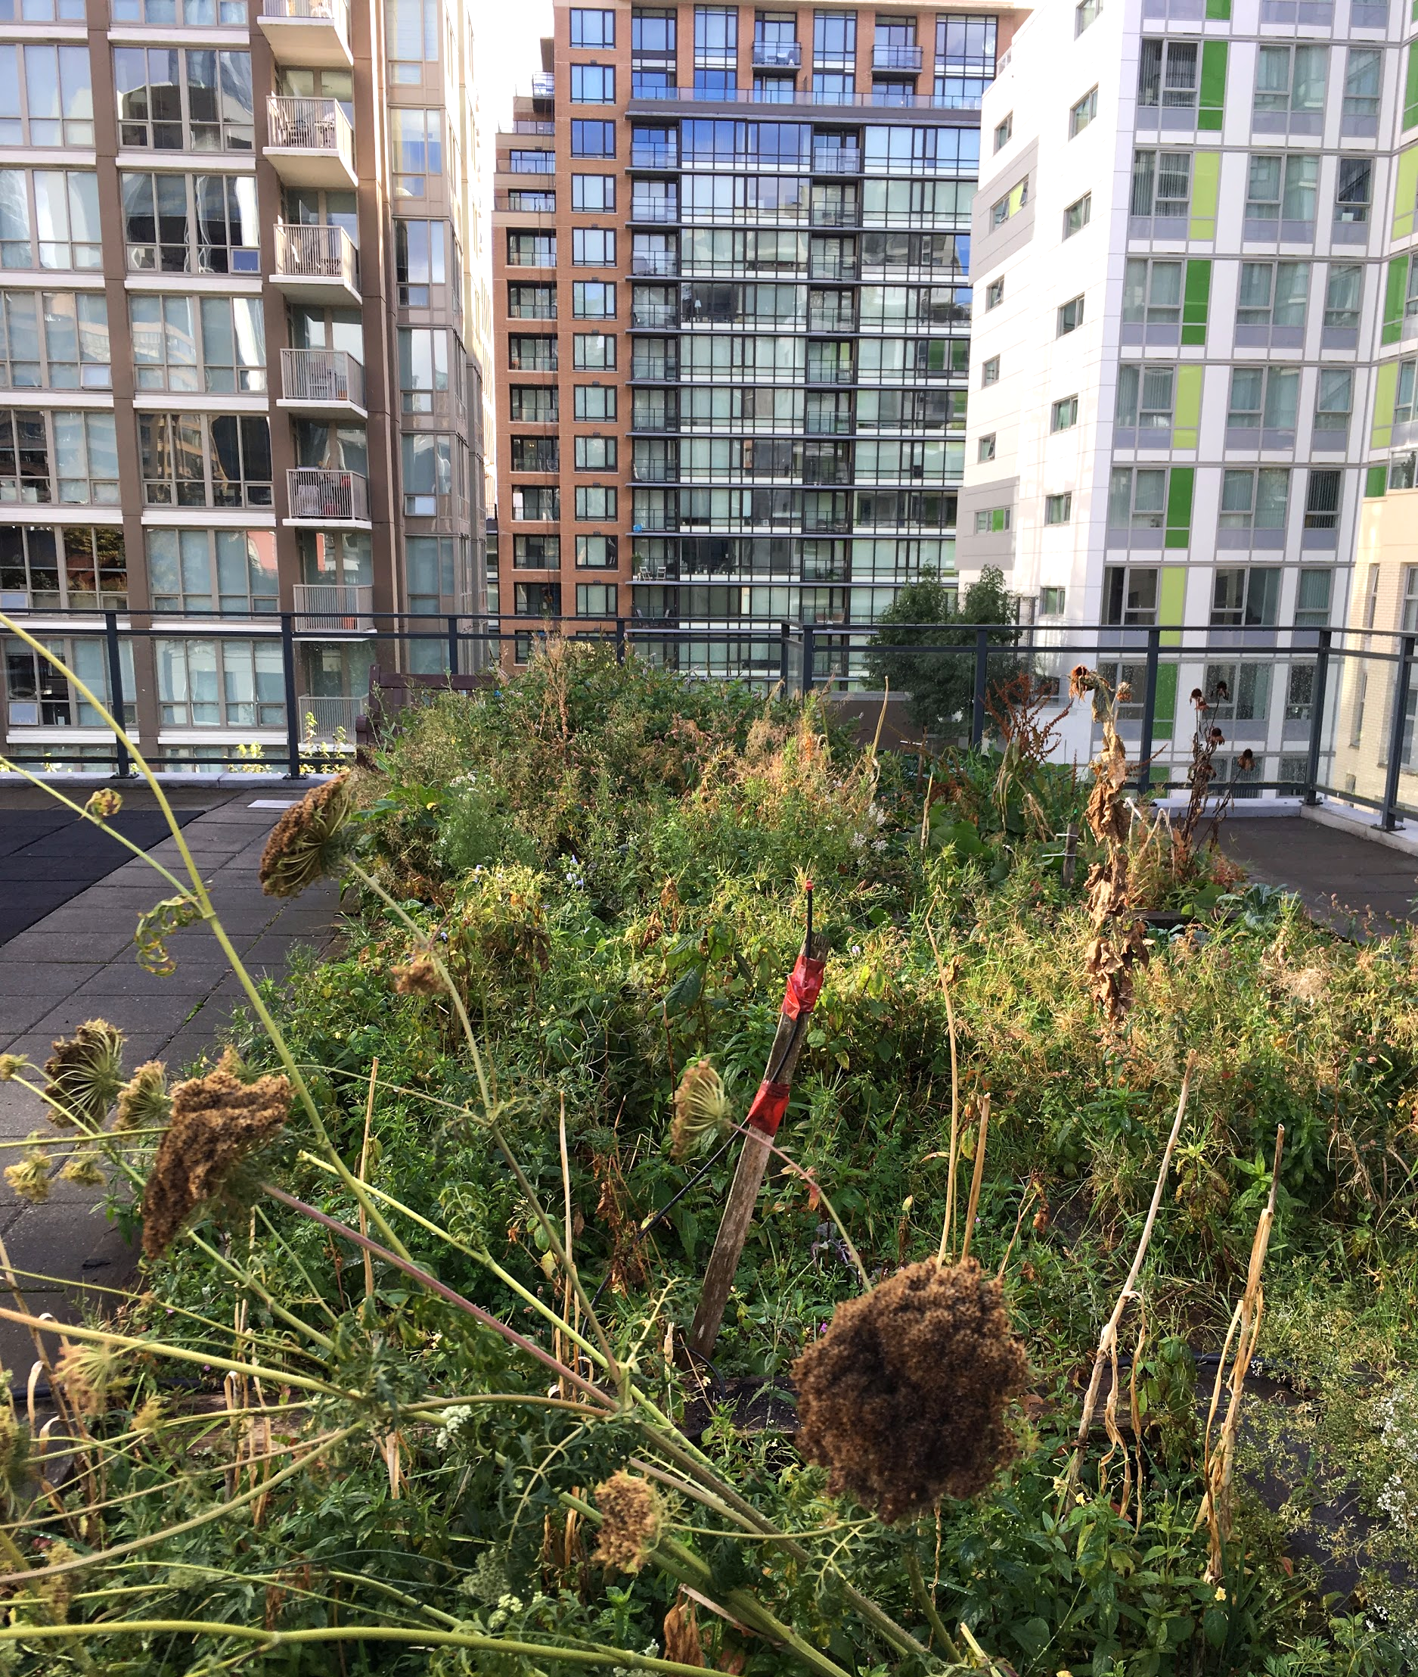

Authors
Lindsay Blair, Stéphane Lahaye, Songpinle Xu, Karina Song, Moeko Maruyama, and Athena Yaoutsis

In collaboration with:
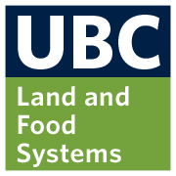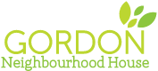

Table of Contents

Introduction 3
Methods 4
Data Collection 4
Data Analysis 4
Ethical Considerations 5
Results 5
Discussion 6
Limitations 7
Conclusion 7
References 8
Appendix A - Blank Harvest Log 9
Appendix B - Total Harvest Summary 9
Appendix C - Survey Questions and Answers 9
Appendix D - Critical Reflections 12
Student 1 12
Student 2 13
Student 3 14
Student 4 14
Student 5 15
Student 6 16

Introduction
The Gordon Neighbourhood House (GNH) lies in the West End of Vancouver and is a member of the Association of Neighbourhood Houses BC. In alignment with other neighbourhood houses, GNH aims to help create “a vibrant and active community” (GNH n.d.a); unlike the others, they place a strong emphasis on the significance of food as a way to “nourish” the community, holding food related programs to provide access to healthy food (GNH, n.d.b). Their emphasis on food programs takes a strong food security and food justice standpoint and focuses on the “dignity” of the beneficiaries of the programs (GNH, n.d.c).
There are currently four GNH community-managed Urban Agriculture (UA) farms in the West End. The food harvested from them is used in other GNH programs, which themselves increase food security and community development. Programs such as the community lunches, Gordon Greens mobile produce market, and the rainbow soup social all reflect their food philosophy “to provide fresh, nutritious, and locally-sourced food in a way that is dignifying for the community members” (GNH, n.d.d).
The world population is expected to hit nine billion people by 2050 (Godfray et al., 2010), and more that 82 per cent of people are living in urbanized areas in North America alone (World Urbanization Prospects: The 2014 Revision, Highlights, 2014). Projects like GNH and others in urban areas are important in the fight to increase food justice and food security. The goal of this project is to develop a way to qualitatively measure and to better understand the impacts of the UA project carried out by the GNH. The data collected will better outline how UA provides benefits that go beyond access to locally grown produce, to provide evidence and demonstrate the value of the programs, and to describe better understanding of the community’s needs. By doing this research we hope to increase knowledge which will help further develop these and other programs in the future and to secure future funding for these programs.
In the end, project participants hope to better understand difficult and often overlapping concepts taught in the LFS core classes and to apply our individual academic background knowledge and unique experiences in a real-world context through community-based experiential learning (CBEL).

Methods

Data Collection
Raw data in the form of the community partner’s (i.e. resident head farmer) harvest log which included the date farming took place, location, name of volunteers, produce harvested, activities, and total harvest volume for each entry was provided to us. Observations and informal interviews were carried out from September to November alongside the community partner and volunteers. In October an online survey was emailed to all the current and previous urban farming volunteers at GNH to collect qualitative data to evaluate the impact of GNH UA program on volunteers’ health and social aspects of life. The questions were generated by members of our group using the Farming Concrete Data Collection Toolkit as a guide (Barry et al., 2015). These questions were looked over and modified by the community partner prior to emailing the surveys to volunteers. Please refer to Appendix C ‘Survey Questions’ for specific questions asked to the volunteers.

Data Analysis
A spreadsheet was created with Microsoft Excel to summarise the entries of the harvest log raw data for an easier quantitative data analysis. Please refer to Appendix A for a sample the Harvest Log. We omitted raw data on the harvest log due to confidentiality reasons. Total volume of produce harvested were calculated for each month in 2017 from February to September, and a bar chart was generated to present this data which can be found at Appendix B.
Volunteer Survey questions consisted of two types: open question where volunteers were allowed to state their opinion freely and closed questions where we have provided a multiple choice selection of answers to choose from. Closed questions were analysed by calculating the number of response for each answer to observe the trend. Open questions were analysed by categorising answers to groups where applicable.

Ethical Considerations
Each member of our group completes the TCPS-2 tutorial on ethics prior to undertaking this project. Confidentiality of the participants was protected by gathering data and survey responses anonymously. Raw harvest data collected from the community partner was not included in any published materials. Consents were established from participants prior to the survey. Confidentiality was ensured throughout the data collection and analysis, and is therefore purposely left blank in this report.

Results
The analysis of the 2017 written coordinator log showed that 44 volunteers participated in GNH urban farming and the total vegetable yield was 277.6 pounds by the end of September. See Table 2 in Appendix B for harvest summary. The monthly yield in pounds of produce is shown in the bar chart below. The yield in summer was much higher than in winter and spring, as expected.

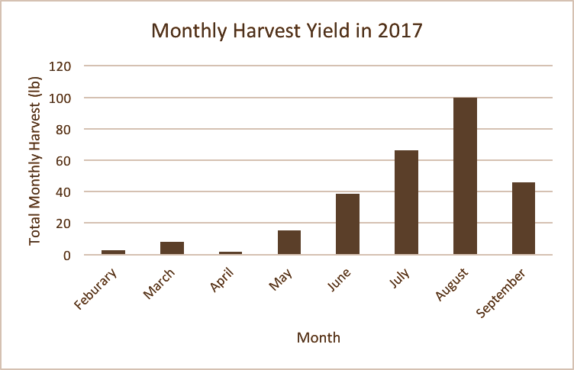
Figure 1: Monthly harvest yields of GNH urban farm sites in 2017.

We received 14 survey responses in total, eight from Google Survey via email sent to volunteers and six informal interviews were conducted with the GNH urban farming volunteers. All respondents and interviewees were more confident about growing and harvesting vegetables, and at the same time, they all reported developing useful gardening skills, including transplanting, winter preparation and composting after participating in the GNH UA program. As for the question that if the program allowed participants to connect with other community members and benefits the community, all of the respondents answered yes to show their agreement. Feedback and suggestions mainly focused on more promotion to attract additional participants and more garden plots to increase yields. See Appendix C for survey results.

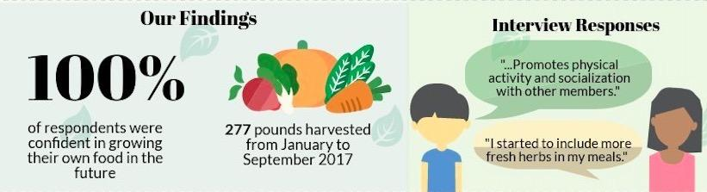

Discussion
Our results show that volunteers who participated in the UA program felt more connected to community members and felt that this program seemed to benefit the community as a whole. The food philosophy at GNH strives to bring the community together through initiatives that build food literacy skills and promote the sharing of healthy local food in the community (GNH, n.d.b); as such, volunteers are benefitting from this program by interacting with other community members, sharing knowledge and learning skills that will allow them to access nutritious foods now and in the future. A survey respondent sums this up perfectly by stating “knowing where your food comes from, who grows it, how it's grown is knowledge everyone should have access to”. All survey respondents reported feeling more confident in growing and harvesting vegetables after volunteering at the farms. The many different growing skills that volunteers have learned from the UA program will lead to increased food security and nutritional knowledge that will benefit the individual and the community (Eigenbrod & Gruda, 2015).

Limitations
A limitation that arose from our methods was gathering online survey responses from past and current volunteers for the UA program in 2017. Out of the 44 volunteers who participated in 2017 we received survey responses from eight individuals. We would have liked to have gathered more responses to see on a larger scale how the UA program has affected people’s relationship with food and the community. To improve upon our design for future research, it would be beneficial to collect survey responses through face to face interviews with the volunteers eliciting a more engaged response from the volunteers since they would be able to openly discuss their opinions on the program (Poulsen, Neff & Winch, 2017).
Another limitation was the inability to attend more of the programs other than the UA farm plots. We would have ideally liked to collect data from end users of the other programs such as the Gordon Greens mobile market and the community lunches to understand in the available programs were meeting their needs.

Conclusion
Through our project, we are able to address the academic research gap in the social benefits of UA program on community development and the lives of citizens beyond local food accessibility in BC province, by analyzing the qualitative data we collected from observations, informal interviews, and online survey responses in the Vancouver West End community. The results and experiences with our CEBL project provide evidence to show the efficacy of community-based UA on fostering community building and educating community members, as it motives networks and social bonds among those who engage in UA and other programs in GNH, as well as it serves as a site to teach people how to grow and where food comes.
Due to the fact that we spent most of the time on farming and taking feedback from farm participants, we didn’t measure the impacts of UA on other GNH food programs, such as community lunches and Gordon Greens mobile produce market. As a result, we recommend students in the future can determine the connection and interactions between UA and those programs in enhancing community food security in further studies. This will provide valuable feedback to GNH as to whether their programs are meeting the needs of the community, where and if they can improve and if new programs are needed.

References

Barry, L., Brelsford, E., Durrant, S., Gasparaska, A., Gittleman, M., Rooney, D., & Silva, P. (2015). Farming Concrete Toolkit. Retrieved November 22, 2017, from https://farmingconcrete.org/
Claire Napawan, N. (2015). Production places: Evaluating communally-managed urban farms as public space. Landscape Journal, 34(1), 37-56. doi:10.3368/lj.34.1.37
Eigenbrod, C., & Gruda, N. (2015). Urban Vegetable For Food Security in Cities. A Review.
Agronomy for Sustainable Development, 35(2), 483-498.
Five Borough Farm (FBF). (2012). FIVE BOROUGH FARM: Seeding the Future of Urban Agriculture in New York City. Retrieved October 2, 2017, from http://designtrust.org/projects/five-borough-farm/overview/
Godfray, H. C. J., Beddington, J. R., Crute, I. R., Haddad, L., Lawrence, D., Muir, J. F., … Toulmin, C. (2010). Food security: the challenge of feeding 9 billion people. Science (New York, N.Y.), 327(5967), 812–8. http://doi.org/10.1126/science.1185383
Gordon Neighbourhood House (GNH). (n.d.a). Mandate and Vision – gordonhouse.org. Retrieved October 04, 2017, from http://gordonhouse.org/about-gordon-neighbourhood-house/mandate-vision/
Gordon Neighbourhood House (GNH). (n.d.b). Food Philosophy – gordonhouse.org. Retrieved October 04, 2017, from http://gordonhouse.org/about-gordon-neighbourhood-house/right-to-food/
Poulsen, M.N., Neff, R.A., & Winch, P.J. (2017). The Multifunctionality of Urban Farming:
Perceived Benefits for Neighbourhood Improvement. Local Environment, 22(11), 1411-1427.
World Urbanization Prospects: The 2014 Revision, Highlights. (2014). United Nations.

Appendix A - Blank Harvest Log
*Due to ethical confidentiality reasons data has been excluded from the table.

Table 1. Blank Harvest Log created for logging farm harvest and activity data
Date | Location | Volunteers |  |  | Weight of Harvest (lb) | Harvested Veggie | Planted Plants | Notes
 |  | Number | Any LFS students? | Names

Appendix B - Total Harvest Summary
Table 2. Total harvest summary for GNH UA farms (February to September)
2017 | Total Harvest (lb)
February | 2.5
March | 8.0
April | 1.5
May | 15.5
June | 38.5
July | 66.2
August | 99.7
September | 45.8
Total | 277.7

Appendix C - Survey Questions and Answers
Questions asked to gain qualitative data:
- As a result of this program, I feel more confident about growing and harvesting vegetables. Choose one:
  - Strongly Agree : 5
  - Agree : 3
  - Neutral : 0
  - Disagree : 0
  - Strongly Disagree : 0
- Did you learn any gardening skills in this program that you will use in the future? If yes which skills?
  - Transplanting, composting, worm fertilizer!
  - Yes, I now know how to transplant plants, and prepare the farm/garden for winter
  - Yes, I did. Yard waste management (composting)
  - Yes, how and when is the right time to sow, to harvest, to allow enough space for each species, etc.
  - I learnt a lot about gardening in general, especially when to plant which crops and how to plant things together. Also how different things grow, what they should look like as they grow, what you should do to help them along.
  - Yes, some planting skills like how deep seeds should be in the soil and what crops we should grow in each season.
  - Yes, learning to plant garlic in the fall was nice to learn
I realised how simple and how little skills it requires to plant vegetable.
- Has the amount of fruits and vegetables that you eat changed because of participating in the Community Garden program?
  - Yes
  - Yes. I was motivated and inspired from seeing fresh produces and I became more interested in incorporating more vegetables and fruits to my meals after participating.
  - Yes, I eat more vegetables
  - A little bit more, especially the herbs that I know grow in my apartment instead of plants.
  - Slightly higher than before.
  - No, it hasn’t. A good and healthy amount of fruits and veggies has always been part of my daily diet as I am a hardcore vegetarian.
  - Not especially, I am already a vegetables lover !
  - Not that I've noticed, but they were a large aspect of my diet beforehand.
- Have you done anything else to improve your diet because of the program?
  - Yes, the program made me think more about what I choose to eat.
  - [Yes] I now choose to eat better foods with more fresh vegetables
  - [Yes] I started to include more fresh herbs in my meals
  - [Yes] I start buying vegetables from farm markets.
  - [Yes] Start my own herb garden!
  - No, I haven’t. I regularly eat healthy and balanced meals, but I am sure it has positively influenced other members participating in the program.
  - Not especially
Did the program allow you to meet or connect with other members in the community?
  - Yes!
  - Yes, it did. I have met people with diverse backgrounds and different interests: learning about harvesting, socializing, English practicing, etc.
  - Yes and they were very nice and involved! The program is a beautiful human adventure.
  - Yes! I met many different people while volunteering and was able to connect with them on many different aspects of life.
  - Yes, three other volunteers from the community
  - Yes,
  - Yes
  - Yes for sure, although it'll be nice to see more people joining the program
- Do you think this program benefits the community? If so, how?
  - I hope so, knowing where your food comes from, who grows it, how it's grown is knowledge everyone should have access to
  - Yes, indeed. It is a great nutrition source for the community as all the produce harvested has been used for the GNH lunches at and the mobile market – it has occasionally supported other food programs like the Friday soup lunch. This program is appealing to those new to harvesting and those not so new, people committed to sustainability and personal health. It introduces new food sources and provides people a sense of appreciation and awareness for food locally grown. Being locally grown at its greatest, it is a valuable step forward towards the reduction of gas emissions related to food transportation. It teaches proper yard waste management (composting) and indirectly promotes physical activity and socialization with other members. "
  - Of course because of the lunches et GNH, the interaction between volunteers, the city in general because of the roof top... It is a virtual circle in which I strongly believe.
  - YES 100%YES! ! I think the program benefits the community in many different ways; encouraging connection between community members who volunteer at the gardens, providing knowledge to the volunteers on gardening and growing food, allowing them to be able to grow their own food in the future if interested; providing a space for knowledge sharing in general (knowledge about food, community programs, Vancouver, gardening etc.); growing food for community members consumption, either in the foodhub or through community lunches etc.; allowing people to get more involved in their food system, raising awareness for the importance of urban food initiatives and community building/connection through food.
  - It provides opportunities for communities members to meet each other. Also some of the harvested vegetables and fruits are used by the community lunch program, which provide nutritious meals with acceptable price to communities members.
  - Yes, definitely. It brings people together, create a positive impact to the food choices, and also I felt that participating in farming helped to me to relax and feel more connected to the food and the environment.
  - Yes, it gives people the chance to eat locally grown food at the community lunches
  - I think that it help people realise how green spaces and gardens are valuable part of the community and should be preserved/increased.
- Do you have any feedback or comments about the program for next year?
  - The days were sometimes pretty long. I would also like to see more community promotion
  - It needs more promotion. Create a similar program for children as it would help them learn about fruits and vegetables and it will likely increase their consumption.
  - Maybe find ways to touch and involve more people.
  - Maybe, encouraging more people (kids and adults) to participate if that is not done already. Maybe having a map of downtown with the locations of urban farms at GNH may make people visiting there more aware about the program
  - I was just sad to have to stop at the end of the summer because the schedule isn't very compatible with my professional life.
  - I really loved being part of this program and am really glad to hear that it will be continuing on; for future reference it might be nice to have volunteer sessions outside of 9-5 work hours, although i know this is difficult considering the staff at GNH would have to work longer; one suggestion there is to possibly have a volunteer who is trained enough to be able to lead volunteers sessions on evenings and weekends.
  - Having more garden plots around the West End would allow the program to expand and contribute more produce to prepare the community lunches

Appendix D - Critical Reflections

Student 1
I had two types of goals for this CBEL project, educational and personal. My educational goal was to gain a better understanding of how an urban agriculture operation functions and to apply the concepts learned in class to a real world situation, and my personal goal was to further explore my interests in food justice, food sovereignty and urban agriculture. This project far surpassed both of these goal expectations. I learned that there is a bigger food justice movement in Vancouver than I originally thought, but I also learned that it is by far not enough to cover the needs of those in need.
Personally I realized that my true passion lies not only broadly in serving food sovereignty issues, but my focus was narrowed to the ecologically sustainable aspect and the policy governing it. I had the chance to make some very good connections in the UA industry and have started to pursue my interests by attending the Vancouver Urban Farming Forum this November. The course was designed in such a way to allow for the realization of both educational and personal goals through using the CBEL format. Saying that, I took away valuable information from class and tutorial sessions that allowed me to deepen opinions and knowledge regarding privilege, or lack thereof. Working with GNH solidified the class teachings and allowed me to see the world through a different set of glasses. The only thing I would have done differently is visit the farm and GNH programs more often throughout the semester.

Student 2
I would say that my experience volunteering with GNH helped me better understand the complexity and challenges of Urban Farming (UF). Until we actually participate in one of those programs, we cannot realize some of the limitations of UF; we might also be tempted to idolize UF as a cure for all miracle. I now release that UF won’t be able to solve food insecurity by itself, but would rather work by supporting community members with additional food during the growing season. This experience helped me better understand that food justice, due to its complexity, also requires a somehow complex approach. Such approach must then be multidisciplinary to respond to the endless variety of profiles and situations involved when it comes to food insecurity.
This course also helped me appreciate how our own privileges can affect our judgments, especially if we are not even aware of them! I found the exercises and online modules done during our tutorials and pre reading very helpful to acknowledge our privileges, which therefore, once we are aware of them, allows us to start working on them and becoming less biased by them. LFS 250 and LFS 350 are definitely very good courses in that aspect since they truly provide concrete opportunities for us students to question and challenge so many of our presumptions.

Student 3
Working on the urban farming project at GNH has taught me hands on gardening skills and also taught me that there is more than one way to address an issue. At the start of the project I had very little knowledge of the food justice movement in Vancouver and the food security initiatives taking place in the West End.
By participating in the urban farming sessions and interviewing members at the community lunches at GNH, I learned that there are multiple ways to address food insecurity. Whether it be through urban farming, community lunches or the Gordon Green Mobile Market, every program strives to increase food security. This made me realize that there is more than one way to address an issue and by having a diverse range of programs aimed at addressing the same issue, the food justice movement will continue to grow.

Student 4
I have enjoyed and am grateful for having able to work on the “Measuring the Impact of Urban Farming” CBEL project along with my team members and Gordon Neighbourhood House. I have always been interested in growing food and acquiring gardening/farming skills and this was a great opportunity as we had the opportunity to help in the farming. Not only that, devoting myself to taking care of vegetable felt very blissful and calming, which I found surprising.
I found goals and actions of GNH inspiring and working with GNH was a great experience for me. One of the things I appreciate the most about working with GNH is how the experience allowed a better and more in depth understanding of some of the theories and concepts of Food Justice in a community scale. GNH adopts the idea of Asset-Based Community Development (ABCD) and seeing how GNH incorporates them enhanced my understanding of the principle and is beneficial. For instance, learning how GNH’s mobile market was a result of listening to the needs of the community and their approach allowed more in depth, solid understanding of ABCD. It was also very inspiring to learn more about the role of ‘food’ in nourishing not only an individual, but also a community through GNH’s activities.
Working collaboratively as a group on this CBEL project was challenging at times, but it was great that LFS 350 class gave me the opportunity to really work as a group on something that is not purely academic, as I feel more prepared to work with teammates in a real-life situation.

Student 5
This CEBL project was an enlightening experience for me to integrate LFS course objectives and concepts in addressing real-life questions around us, and to acquire problem-solving strategies and communication skills while we designed and conducted our project. I am so glad that I had the chance to collaborate with awesome teammates from different LFS majors and our kind community partner. They inspired and motivated me a lot, especially at the beginning of the project, as I totally had no idea what we mean to do. However, I started having the clear frame of our project through frequent group discussions and meetings with the community partner. From this, I realized the significance and power of group work in refining understanding, pool knowledge and skills, and receiving encouragement to take risks.
What’s more, after engaging in Gordon Neighborhood House, I gained a deeper insight into the ways it operates and the roles that it plays in the neighborhood. Both neighborhood house and UA program were new concepts for me since such organizations that aimed to improve community food security were rarely seen in my hometown. This enabled me to understand how effective those organizations and programs benefit the neighborhood in a way of assisting community building and people reconnection. Overall, it was an enjoyable and invaluable experience when we devoted our time to farming and project development.

Student 6
Over the course of 4 months doing this course, my understanding of food justice definitely changed. While we learned a lot of these concepts in class and some real-life examples of injustices that occur in many different places, I’ve always felt I was removed from the situation. In other words, these real-life consequences felt too detached to me and I couldn’t fully picture the impact of these consequences. However with the CBEL project, it really grounded the realities of food insecurity and the importance community development in my mind. By talking with the community sponsor, I was able to learn how implementing food security and food-related community development initiatives can be quite difficult and time-consuming. In addition, a lot of trial and error is involved in these processes. For instance, the farmer planted tomatoes in one of the rooftop gardens but the location of the garden was a ways off from Gordon Neighbourhood house. As a result, the garden was visited less frequently compared to the closer gardens. As a result, the tomatoes did not grow well as they need more regular care. From this experience, the farmer will refrain from planting tomatoes in that garden again and instead plant sturdier crops. Overall, I would have to say this experience was definitely worthwhile as I feel my understanding and worldview has expanded. I think I will be able to evaluate food-related current events and policy changes in a new, critical light.

