Burnaby Artisan Farmers’ Market: “First Choice Market”
Group 22: Katie Bartel, Emma Burger, Hongpu Gu, Rachel Mah
University of British Columbia
December 3rd, 2017

Introduction:
The purpose of this research study was to determine the aspects of Burnaby Artisan Farmers’ Market (BAFM) that attracts farm vendors, and the reasons why they stay or leave. The Artisan Farmers’ Market Society operates the Burnaby market, as well as Lonsdale and Ambleside farmers’ markets. BAFM has operated since 2008 at Burnaby City Hall. Although modest, compared to bustling Vancouver markets, BAFM offers a relaxed experience creating opportunities for patrons to converse with farmers. Yet, it has recently faced challenges in retaining vendors. This could be due to the unusually poor weather conditions of the 2016 season, or possibly something more operational (T. Immell, personal communication, September 20, 2017). The intent of this project was to discover the assets and limitations of BAFM from the perspective of its farm vendors through data analyzation, in-person interviews and a nominal-style survey. Understanding the needs of farm vendors is paramount to the success of the farmers’ market (Campbell, 2014).

Significance:
Farmers’ markets are an alternative food pathway to big box grocery stores, offering consumers an outlet for healthy, local foods, and farmers a venue for marketing and selling their goods (Stephenson, Lev & Brewer, 2008). They are a backdrop for food justice, which invokes the elimination of disparities between community members and their interactions with healthy foods, by contributing to the economic, environmental, and social health of communities equitably (Gottlieb & Joshi, 2010; Stephenson, Lev & Brewer, 2008). BAFM has been operating for nine years, and has recently struggled to retain its vendors. Last year the Artisan Farmers’ Market Society reported a $17,000 operational loss. That means $17,000 more was spent than what was earned in stall fees for the year. That is a significant deficit for the nonprofit organization that relies on fundraising initiatives, grants and vendor fees for operating.
Smaller markets are often considered second-choice markets for farm vendors (Stephenson et al., 2008). Trout Lake, one of Vancouver’s busiest markets, brings in approximately 70 vendors each week; BAFM averages 35. Farmers are more likely to sell at markets where they are assured a solid customer base and the ability to sell the majority of their product in the time provided (Stephenson et al., 2008). Does BAFM offer that element to its farm vendors, or could it do more? This study was designed to uncover that.

Objectives:
Objective 1: Conduct in-person interviews and distribute an online survey to
farm vendors active between 2014-2017, using self-generated questions, and
questions from a previous survey conducted by BC Association of Farmers’
Markets (BCAFM).
Objective 2: Analyze data from surveys and interview results, and create graphs
categorizing the responses.
Objective 3: Produce a report that outlines the assets and limitations of BAFM through the perspective of its farm vendors.

Methods:
Vendor applications from 2014-2017 were transcribed to Excel. Farm vendors active throughout that period were used for the study’s population demographic. In-person interviews were conducted with seven farm-specific vendors over two market visits. Interview questions included:
1. Why did you choose BAFM?
2. Why do you continue to sell at BAFM?
3. What elements of BAFM do you enjoy?
4. Are there aspects of BAFM you would improve?
An anonymous, Google Form survey was designed and distributed to 34 past and present vendors via email (see Appendix A). Researchers followed up with vendors by phone and email a week after the survey was distributed. Data was analyzed and categorized based on assets and limitations. Researchers discussed findings with the project partner.

Ethical considerations:
Researchers completed the Tri-Council Policy Statement (TCPS) and used it as a framework throughout the project. A consent form was distributed with the survey (see Appendix A). Permission was requested for each in-person interview, and all documents have been stored confidentially.

Results:
The total demographic included 12 farm vendors. Of that, 7 were interviews, and 5 were survey responses. Combined, the most significant asset cited was the people at 64% favorable, which included customers, fellow vendors, and the market manager (see Table 1). On-site parking was another unique attraction for several vendors, especially those coming from out of town:
“A lot of markets have issues with parking,” said one vendor.
“Here, we don’t have to find a space to park the truck and then trek all the produce in from a long distance,” said another vendor.
The location, space, support from the association, as well as a system that is not so stringent with rules were also considered assets.
“It’s a better opportunity for personal experience here, as opposed to Vancouver Farmers’ Markets,” said one vendor “[Vancouver is] so busy, and very rules based.”
“I like the size of it,” said another vendor. “It’s comfortable.”

The data from the online surveys and in-person interviews was also analyzed separately, due to the fact that vendors were able to ask questions during the in-person interviews, which could vary results (see Table 2 and 3).
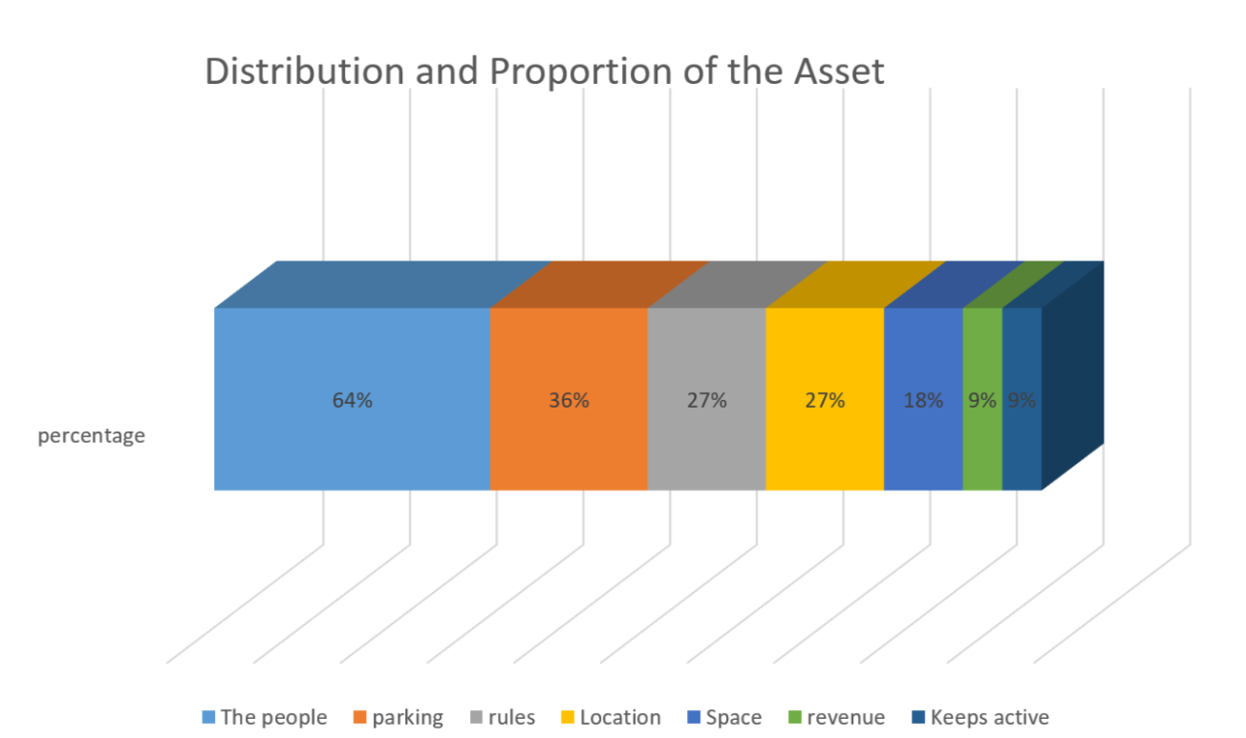
Table 1: Combined In-Person Interviews and Online Survey Vendor Data
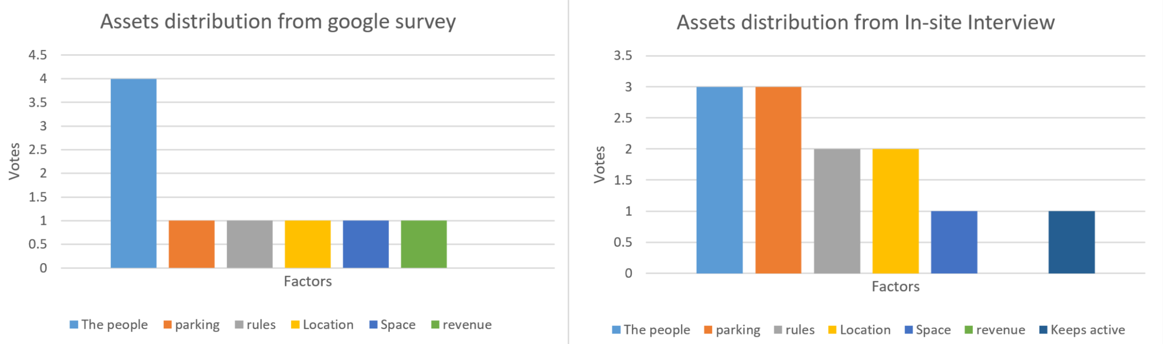
Table 2: Google Survey Vendor Results Table 3: In-Person Interview Vendor Results

Of the responses, there are very few limitations listed, which were varied (see table 4). Low revenue and lack of stability were the factors that had multiple responses compared to the others. One vendor noted “reselling” as a cause for concern. Reselling is when vendors sell product that is not their own (T. Immell, personal communication, Oct 7, 2017). The Artisan Farmers’ Market Society is built on the premise that everything it sells is made, baked, or grown locally; reselling is forbidden, and vendors will be asked to remove their product.

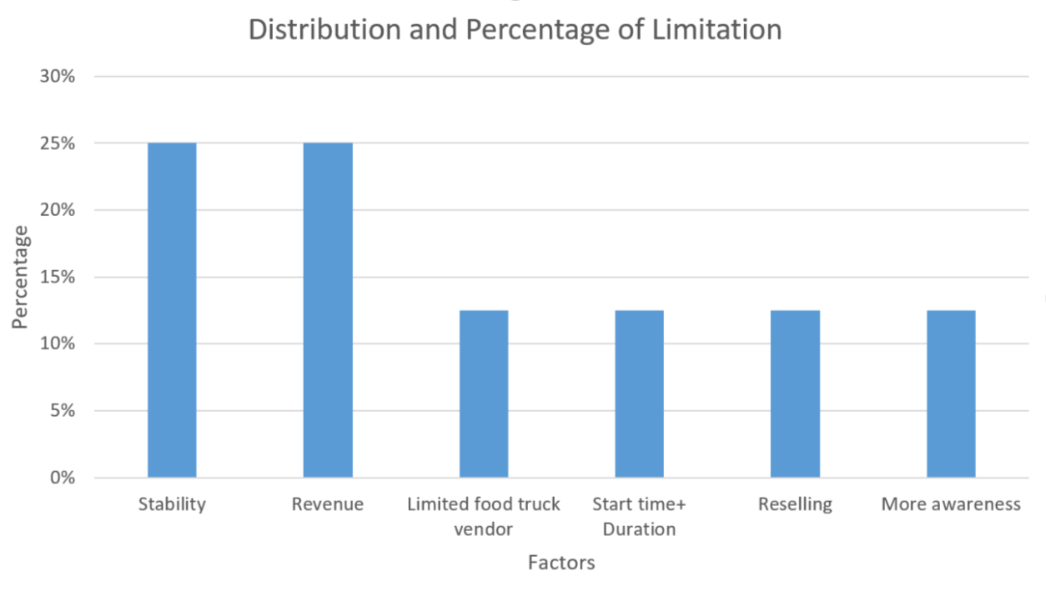
Table 4: Limitations of Burnaby Artisan Farmers’ Market

Discussion:
Understanding the needs of vendors is imperative to a market’s success, and further increases food justice in a community. The assets obtained in this study far outweighed the limitations. All farm vendors that participated in the in-person interviews shared glowing accounts of the Burnaby market. Stephenson et al. (2008) reported that small market size is one of the top five factors of market failure; yet, the results of this study contradict that. The most significant finding of this study was the inviting environment created at BAFM by the people. More than half the respondents continue to sell at the market because of their tight relations with their loyal customers, fellow vendors, and the market manager. Another unique asset repeatedly reported on was the conveniently located vendor designated parking, which many other farmers’ markets in the Lower Mainland lack.
Study participants had very little to report on for limitations. The survey responses showed revenue and stability to be the most limiting factors with two votes for each that came from past vendors (see Table 2). However, this contradicts the qualitative data obtained from the in-person interviews, where some of the farm vendors reported revenue and stability as an attraction. It is interesting to note that vendors who had been selling at BAFM for several years, with a stable customer base, described Burnaby as a “grocery style” market that resulted in higher revenue than the Vancouver markets. Overall, the majority of farm vendors who participated in this study were overwhelmingly satisfied with the operations of BAFM.

Study Limitations:
A limitation of this study was the population size. Of the 34 surveys distributed, there were 5 responses, bringing the total population to 12 with the 7 in-person interviews. It is unclear if the findings are a true representation of the market as a whole, and thereby reduces the quantitative evidence collected. As well, utilizing online surveys as a method for data collection could also be limiting, especially for vendors who are not computer savvy. To overcome these limitations, it is recommended future researchers inform vendors in person of the surveys, as well as distribute paper copies of surveys to complete on site. These actions would likely help increase the response rate.

Conclusion:
Despite being informed by our project partner that smaller markets like Burnaby are often second-choice markets to larger markets, the findings of this study showed otherwise. Every current farm vendor we spoke to told us they specifically chose Burnaby. They praised the organization, and had very few complaints to speak of. This shows that small markets have value in the eyes of farm vendors too. However, due to limited responses from former vendors, we do not have a clear understanding as to why those vendors chose to leave Burnaby. It is recommended future researchers widen the scope of the study to all farm vendors listed as members of BCAFM as a way of understanding why BAFM is not a first choice for those vendors. Still, in light of the significant assets listed by its current vendors, it is recommended BAFM continue to build on the areas it is excelling in, and exploit its assets, especially the parking, as a way of attracting future farm vendors.

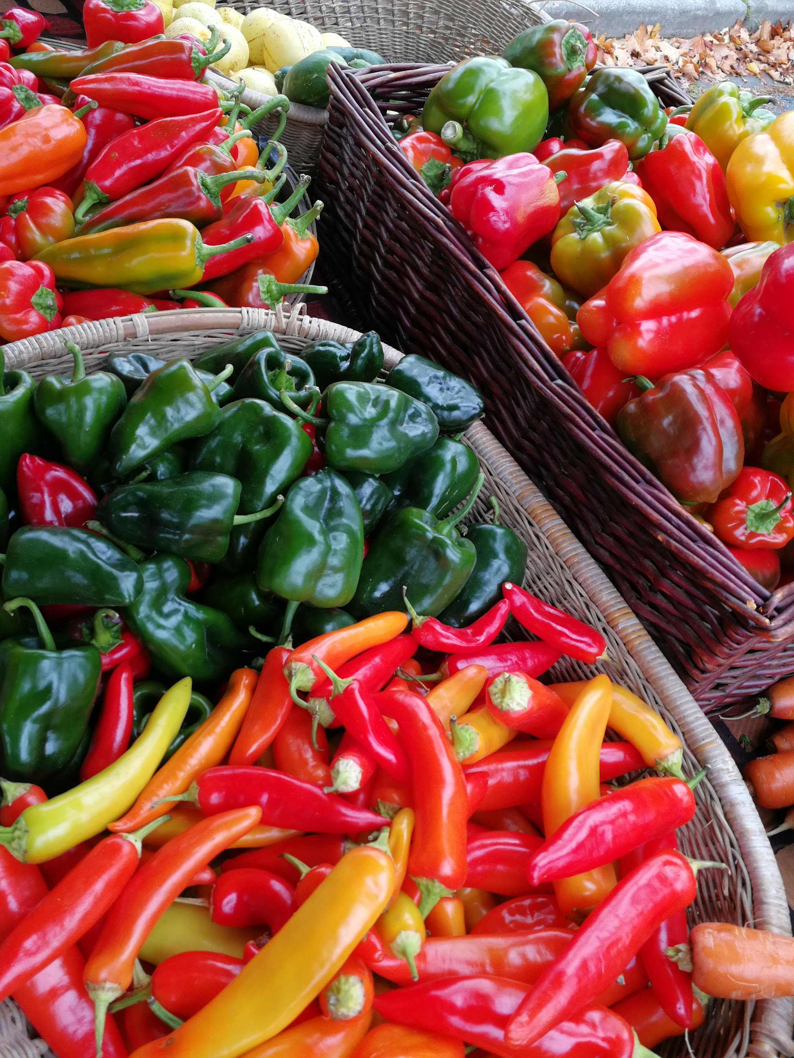

REFERENCES:
Campbell, J. (2014). Cooperate or compete: the relationship of strategic orientation and
firm performance for farmers’ market vendors. Journal of Small Business &
Entrepreneurship. 27(1), 27-42. doi: 10.1080/08276331.2014.932965
Gottlieb, R., & Joshi, A. (2010). Introduction: Taking root. Food Justice (pp. 1-10).
Cambridge, Mass: MIT Press. Retrieved from http://muse.jhu.edu/chapter/
787848
Government of Canada. (2015). Core Principles. In Tri-Council Policy Statement -
Ethical Conduct for Research Involving Humans (Chapter 1). Retrieved from
http://www.pre.ethics.gc.ca/pdf/eng/tcps2-2014/TCPS_2_FINAL_Web.pdf
Mathie, A., & Cunningham, G. (2003). From clients to citizens: Asset-based Community
Development as a strategy for community-driven development. Development in
Practice, 13(5), 474–486.
Stephenson, G., Lev, L., & Brewer, L. (2008). ‘I'm getting desperate’: What we know
about farmers' markets that fail. Renewable Agriculture and Food Systems,
23(3), 188-199. doi:10.1017/S1742170507002153

APPENDIX:
Appendix A. Google Form Survey
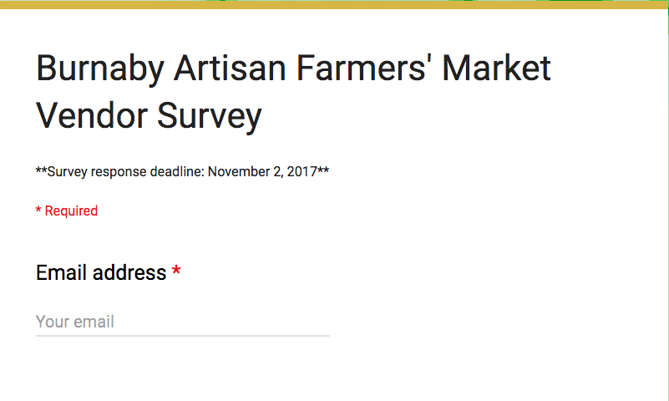
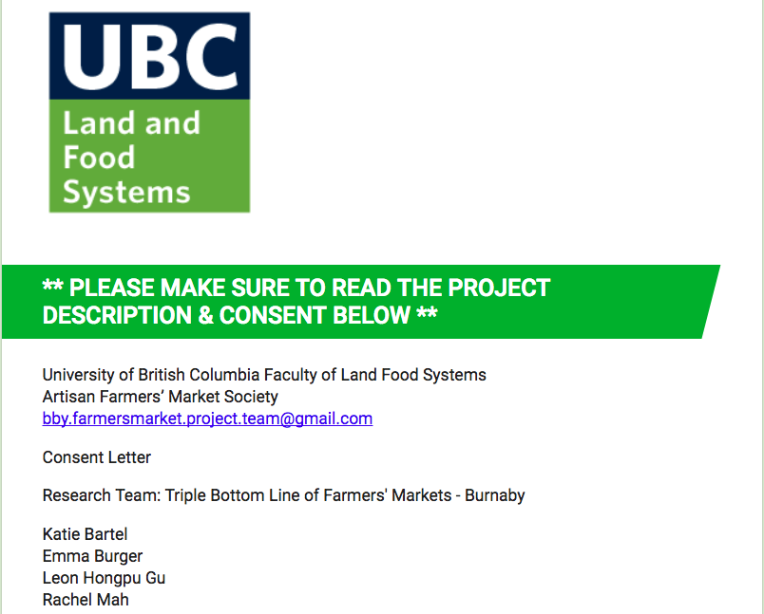
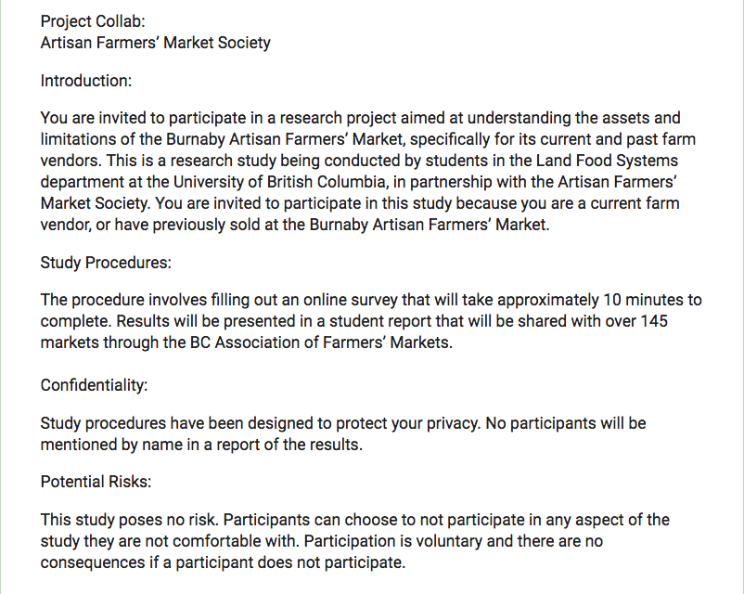
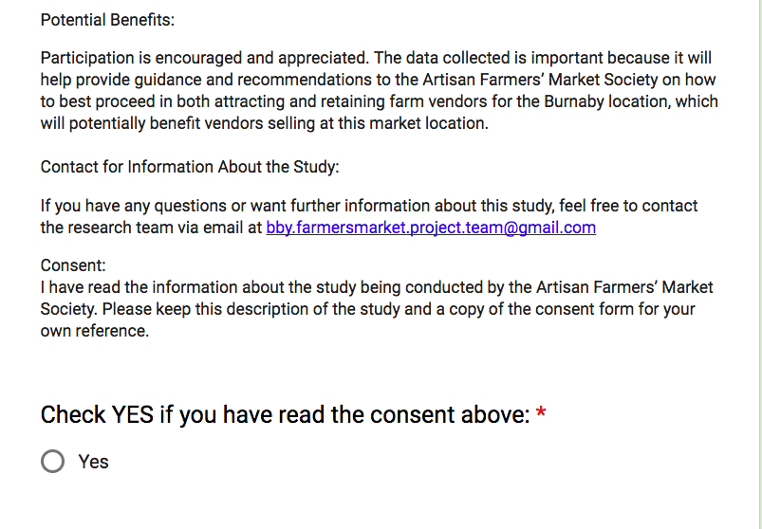

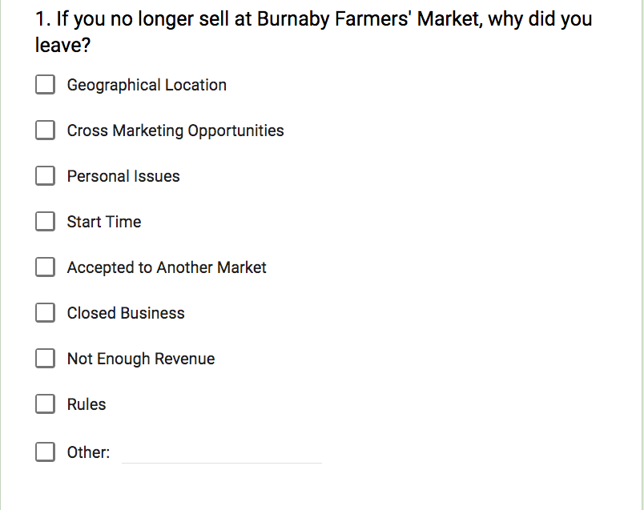
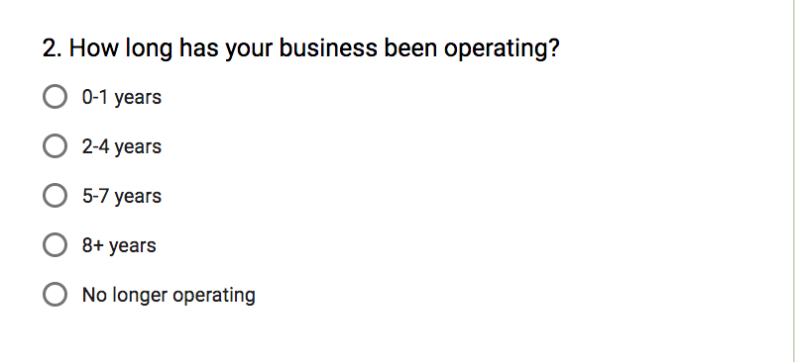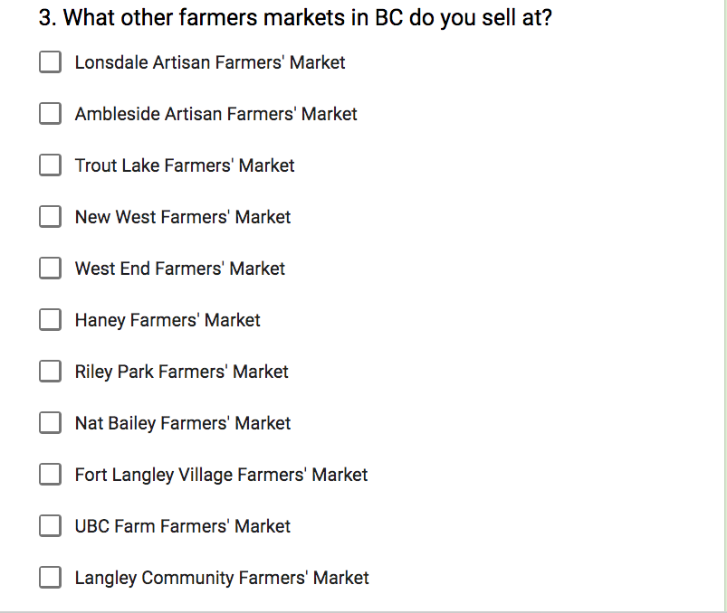

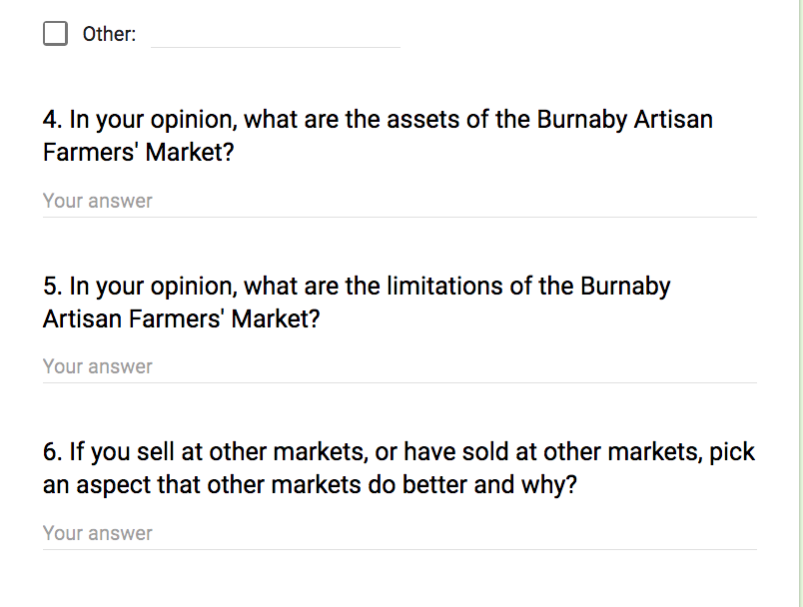
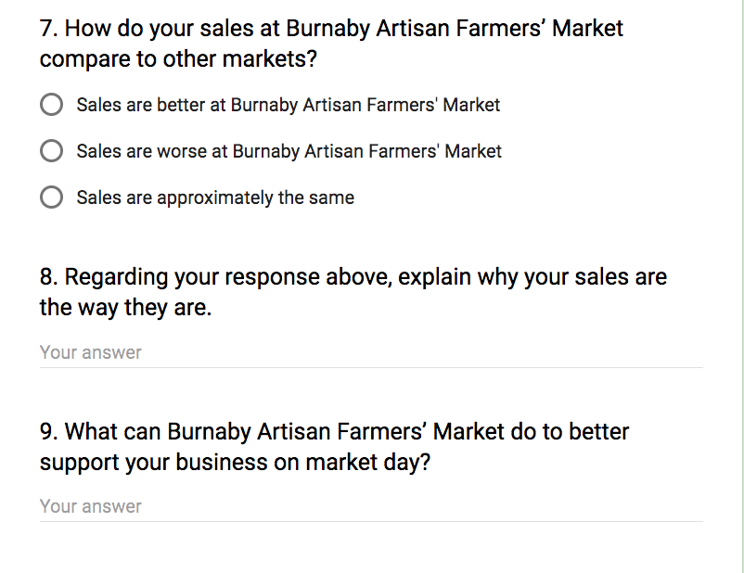
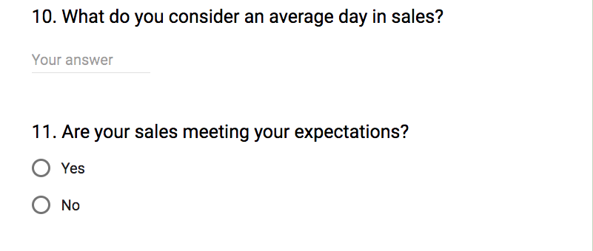

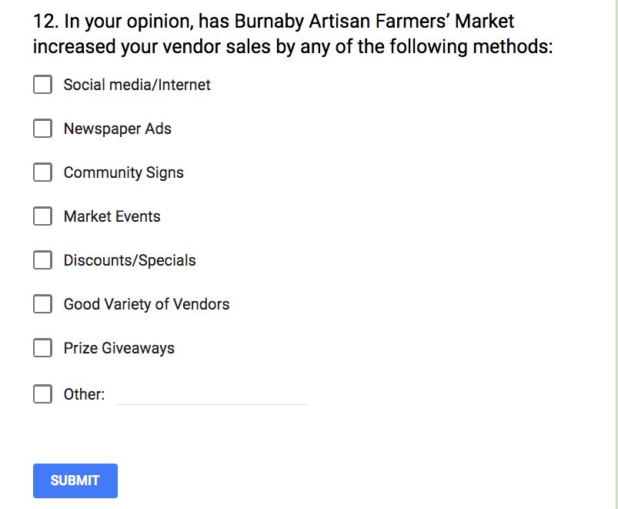

Critical Reflections:

Student 1:

My understanding of the issues of food justice has grown throughout this semester working on the Burnaby Artisan Farmers’ Market CBEL project.

Prior to CBEL, farmers’ markets to me were all about the farmers, and how they were providing my community an alternative, fresh, locally grown food system. I didn’t think much about the challenges this system presented for lower-income, elderly, or health-challenged individuals. While I recognized produce cost was a hardship for some, other aspects of accessibility, I did not see – until this project.

My understanding of food justice is that it’s about providing an equitable food system where all people have the right to grow, buy, and eat healthy foods. While farmers’ markets provide an alternative system for farmers to sell and consumers to buy healthy foods, it’s a system that currently is not widely accessible to the population as a whole. And it took experiencing it, rather than reading it, to fully grasp it.

The location in Burnaby, for example, while central at City Hall, is not easily accessible: it’s surrounded by busy roads; parking lot access is challenging; and public transit is costly and time consuming. It took physically driving there, and driving around in circles trying to access the entrance, for me to take pause and think about other issues of accessibility that farmers’ markets present.

In this context, food justice is about satisfying both market vendors and the market community. Is that possible? Honestly, I don’t know. But it was comforting to learn that BAFM is working with marginalized community groups to try and fill the gap at their market.

Student 2:

For the significance that food justice holds within our food systems, I am surprised at how unacquainted I was with the concept. Since day one of LFS 350, I would not have been able to give a clear answer to what food justice is. The lectures and tutorials obviously expanded my comprehension around the concept, however I found that writing my Academic Experiential Review (AER) paper and participating in my community-based experiential learning (CBEL) project, really influenced my greater understanding.
I based my AER paper on how racial and economic equality is necessary for increasing food justice in communities - focusing on farmers’ markets in the Vancouver area. Throughout my research, I was quite amazed at how many farmers’ markets were not achieving food justice because of their lack of racial and economic equality. This is seen quite often, whereby farmers’ markets primarily offer goods and services that cater to community members of white race, instead of the diversity of races that are situated in the community.
I also became aware of how important it is to utilize asset-based community development (ABCD) when trying to help a community improve food justice. During our CBEL project, our research contradicted what we found at Burnaby Artisan Farmers’ Market; therefore, by going to the market and conducting in-person interviews, we were able to understand what the vendor's actual assets and limitations were and use them for more effective recommendations. Overall, I have a noticeably broadened my understanding of food justice, and I am now confidently able to explain what food justice is.
Student 3:

My understanding regarding to the concept of food justice has grown throughout this semester working on the Burnaby Artisan Farmers’ Market CBEL project.

Before the CBEL, the concept behind farmers’ market to me is the place to spend leisure time in and a place for the education of the next generation about the sustainability and the basic concept of food. After the CBEL, I found out that it is more than what I thought to be, also a insufficient market that not everyone could benefit from.

The concept behind the food justice is providing an equitable food system where all people have the right to grow, buy, and eat healthy foods. While farmers’ markets provide an alternative system for farmers to sell and consumers to buy healthy foods, it’s a system that is currently incomplete and unsustainable.

The food market in our project runs from 9a.m. to 2p.m. every saturday. That is the only day the market is running in one week. Also the price in the farmers’ market is actually higher than that in a Chinese-Canadian farmer run grocery which has more abundant choices of both vegetable and fruits. Indeed the grocery owners don’t grow all of the product in their store, but over 70% of the product is actually grown by themselves. On the other hand, the groceries run 7 days a week and is located within the community. So what is the meaning of the existence of the farmers’ market other than education and relaxation?

As for the equity, burnaby’s artisan farmers’ market is located in the center of burnaby, an area consisting over 50% of Chinese-Canadian resident in its population, yet not even one vendor is selling a culturally appropriate food for this great population. At least I didn’t see any equity.

Interestingly enough, the managers are aware of and admit the role Chinese-Canadian farmers and residents are playing in the food system within metro Vancouver area, yet they didn’t take any action.

In conclusion, the food justice to me is a concept that need to be improved or specified when it is applied to practice.

Student 4:

When the community projects were announced in class, I was anxious and unsure of how I was going to contribute to addressing community food security challenges. Although I knew the definitions of food justice, food sovereignty, community food security, and food security, I wasn’t able to fully grasp the concepts or fully see the lack thereof facing the communities around me.

The readings and lectures, helped expand my interpretation of the concepts, but I was still constantly going back to the definitions and comparing it to what I was reading. I understood that there were disparities and inequities in our food system that needed to be rectified, however, it was not until we got to apply as well as experience what we learned in class to the CBEL project that I really understood.

With the project, I was given the opportunity to learn more about the issues of food security in the world of the small producers in our local food system. Listening to Tara speak about the challenges the Society has recently faced, her strong passion and excitement for the project was contagious. Albeit, as we learned in our readings, there are barriers to engagement and farmers’ markets have a ways to go in actually increasing food justice in communities.

Throughout the term, my understanding of food justice was continuously growing, changing, and being filled out in my head. I began to realize that there are many more factors that come into play when thinking of food justice.

