LFS 350 Community-Based Experiential Learning
Project Report

Sole Food Street Farms: Documenting the Big Move
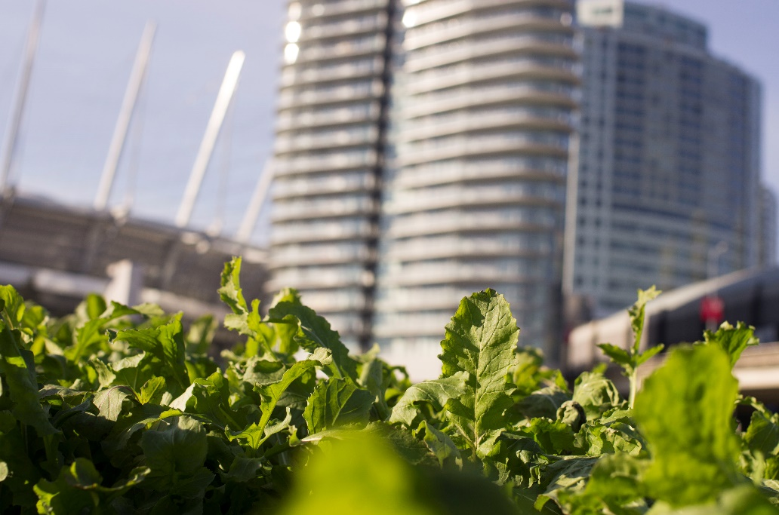
Source: Spencer Cain

Spencer Cain
Andrew Lang Wong
Nikita Payne
Yevgeni Petukhov
Bonnie Wu

Introduction
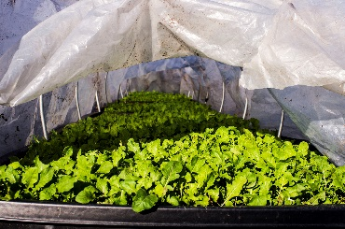

Source: Spencer Cain

Sole Food Street Farms is a group of four urban farms located in the Greater Vancouver area that were created over the past seven years by cofounders Seann Dory and Michael Ableman. Sole Food's mandate encompasses educating and nourishing people through agricultural training, developing jobs for people who have struggled with substance abuse and poverty during their lives in the Downtown Eastside, and producing artisan-quality food (Sole Food, 2017). They use land that would otherwise be vacant in the Vancouver area such as undeveloped gas station lots. This project documents the move of Sole Food's urban farm currently located at the corner of Pacific and Carroll to the other side of the Cambie Bridge (215 West First Street). Sole Food had to relocate as their lease expired for their plot owned by Concord Pacific, and they were required to vacate by November 24, 2017.
The goal of our project with Sole Food was to document the physical move, and the processes required to be completed beforehand, of one of their urban farms in Downtown Vancouver. A large emphasis was on the physical move itself; however, we feel that to understand all that is required to move an urban farm, the proceedings that occur before are critical to document as well. Our objectives were to produce a visual record of the procedures that functioned smoothly during the move, and to provide feedback on challenges faced during the move that could be improved in the future. The stated objectives will help to illustrate ways to increase the efficiency of urban farm relocations in the future.
The urban agriculture (UA) movement has gained popularity in North America in the last decade, fueled by its progressive approach to social issues, economics, and sustainability (Walker, 2016). While UA does not necessarily have the immediate potential to increase food access and change supply chains, it does build closer relationships between urban citizens and their food (Thibert, 2012). Organizations such as Sole Food aim to use vacant land within the city to create a community food system amongst urban food deserts. To achieve this goal, Sole Food created “mobile farms” which are contained within portable boxes designed to be transported between vacant urban sites (Valley & Wittman, 2016). However, the logistics of this mobility have yet to be tested, and our project attempts to identify their practicality and document the process of moving Sole Food's largest farm site.
Despite the growing popularity of the UA movement, Thibert (2012) claims that municipal governments in North America have not concerted enough effort into creating policy that favors' UA projects, often hindering their progress. However, the City of Vancouver aimed to improve and expand UA through the Greenest City 2020 Action Plan, and created policy to achieve these goals (Walker, 2016). Our project addresses the many steps that are taken when establishing and moving UA projects such as permits, policy, and the physical act of moving the operation.

Methods
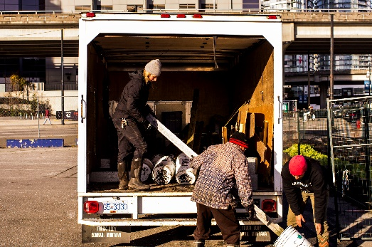
Source: Spencer Cain

Prior to producing our documentary, training on research ethics was received by all members of our group and a TCPS-2 certificate was obtained. To proceed with the filming, consent forms were created for those who wish to appear in the film. This was to ensure we have informed the participants of how we will be using the content as well as a written proof of their consent. A draft of the consent form was sent through email to be reviewed by Matt Johnstone before filming.
Three interviews were planned to be conducted with the anticipation of additional interviews for the employees who would like to participate as well. The three interviews planned were with Michael Ableman, Co-founder of Sole Food, Matt Johnstone, Administrative Director, and Andrea Wilkins y Martina, Director of Farm Operations. Unfortunately only interviews were conducted with Andrea Wilkins y Martina and Matt Johnstone as Michael Ableman was unavailable. Interviews of the staff aimed to highlight issues that will affect them as a result of the relocation and their own personal thoughts and opinions. Such issues aim to capture the move and its effects within the community as well as economically to document for future urban farm moves.
The filming portion of the project was carried out through multiple trips to capture the 3 stages of the move, the before, during and after. The first shooting was held on November 8th to film the “before” stage and the second shooting was held on November 10th to capture the first days of the move. Subsequently, multiple visits to the old and new site was made to capture the “during” stage, and interviews were also held during this time. The last shooting was held on last day of the move on November 21st. The collected footages were then processed and edited into a 7 minute video. The final products of this project including the video, infographic, and final report are to be sent to our community partner, Matt Johnstone.

Results
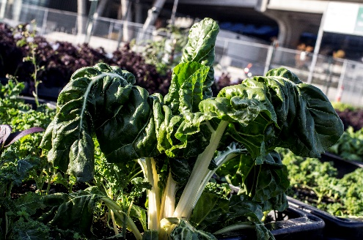
Source: Spencer Cain

Our project didn't result in any numerical data but rather in the form an informational video. The video we produced is our representation of the data collected. The video demonstrates that the most difficult aspect of moving an urban farm are the preparation stages. Before the move could occur there first needed to be another plot of land approved for Sole Food to relocate to. In order to use the land Sole Food first needed to acquire the proper leases and permits pertaining to their move. Obtaining the permits was a lengthy process, and for any future moves should be started as far in advance as possible, because Sole Food almost didn't obtain their permits and leases allowing them to relocate in time. Once the permits were approved the move could commence. The physical move of the farm was not difficult but was still quite time consuming. The entirety of the move took roughly two weeks, from November 8th to 21st. As much preparatory moving was completed before the actual planter boxes were transferred. The irrigation system and any extra materials such as fencing and supplies were moved to the new farm location to prepare for the largest component of the move which was the arrival of the boxes at the new location. The move of the farm went relatively well for Sole Food with no major issues. For future moves we suggest that in order to have less stress on the timeframe of the move it would be better to obtain the permits further in advance as Sole Food had to vacate their lot on November 24th, 2017, and they obtained their permits only 3 days in advance.
We also found that land in the Downtown Eastside has become significantly harder to acquire since the inception of Sole Food almost 9 years ago. Due to Vancouver's housing boom, there is much higher demand for land, and vacant spaces are few and far between, making the farm's initial mobility a harder concept, especially for other organizations looking to employ a similar concept. There is minimal room in the heart of the city for other organizations such as Sole Food; however, there is a much greater abundance of vacant space in the outlying sections of the city. One factor that Sole Food has that may ease the process of finding suitable vacant land is the use of raised bed containers. More options become available to them such as contaminated gas station lots, as they are not growing from the ground they occupy.
For more information regarding the findings of our community project please visit the LFS 350 website where our video will be posted for the public or the link provided below.

Discussion
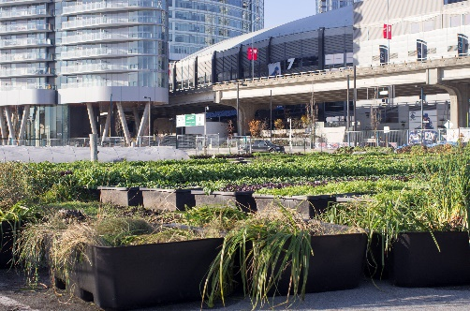
Source: Spencer Cain

Our findings are both encouraging and disheartening regarding applications to future urban farming operations. Through our interviews and video documentary, we witnessed the successful relocation of Sole Food's largest farm with minimal setbacks and accidents. Despite the opinion of Thibert (2012) stating that North American cities had not concerted enough effort into creating policy that favors UA projects, we concluded that the City of Vancouver has contributed and aided Sole Food in their move, and continues to promote UA projects. Unfortunately, we also learned that land in the core of Vancouver is increasingly hard to secure for UA organizations, and there is limited room in the heart of the city for operations as productive as Sole Food. Furthermore, we can conclude that initiatives such as Sole Food do indeed build closer relationships between urban citizens and their food (Thibert, 2012). The employees at Sole Food were urban citizens who had come to appreciate and build knowledge about growing and harvesting food. It should be noted that our results only include the experience of a single UA organization in Vancouver, with a prominent founding figure (Michael Ableman) and a long history of financial and government support. Other, smaller organizations may be experiencing difficulties with other aspects of farm relocation or when working alongside the city. It would be interesting to interview other UA organizations in Vancouver to compare their experiences, and look into the difficulties they face.

Conclusion
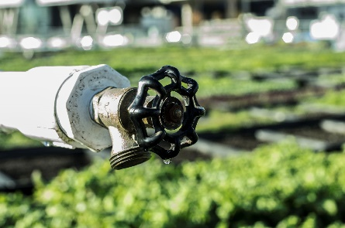
Source: Spencer Cain
Through the video documentation of Sole Food's move, we have illustrated versatility of Urban Agriculture (UA) to sprout up in vacant lots and move when those lots are needed for other uses. The Sole Food move has demonstrated that urban agriculture is maximizing food production in an urban environment because it can be set up and transported with relative ease. According to the 1996 World Food Summit, Food Security “exists when all people, at all times, have physical and economic access to sufficient, safe and nutritious food to meet their dietary needs and food preferences for an active and healthy life” (Food and Agriculture Organization, 1996). Industrialized farming practices, such as monoculture crops, have drastically changed the food landscape in the country, and the globe. The implications are that more people are departing from agriculture and moving to cities instead of taking up farming. The move, but specifically the documentary, proves that urban agriculture can succeed in an urban environment in the face of growing demand for land space and availability. Positive feedback from the success of the move helps to validate the claim that UA can successfully improve physical urban access to healthy and safe food in a city like Vancouver. The exodus of citizens from the food system to more contemporary urban living has allowed for the consumer to lose control, but rather become detached from the control mechanisms in their own food system. UA represents a means for the community to reconnect to their food system. Food Sovereignty is defined as “the people who produce, distribute, and consume food should control the mechanisms and policies of food production and distribution” (Global Small-Scale Farmers, 2005). Metropolitan dwellers are disconnected from the food system via lack of access, and knowledge to traditional farming practices. This has resulted in the consumer to lose control of the mechanisms, which allow them to access food. UA can successfully reengage the urban dweller into their food system. This is another added benefit of the Sole Food documentary. The documentary can be shown to a wider audience and hopefully cause a change in their understandings of the food system and how the community involvement can be an integral factor to address issues related to food sovereignty and food security.

Appendix
Critical Reflections
Student 1:
Through my time with the LFS 350 course and instructors, I’ve learned so many things about world food justice and food related issues worldwide. LFS 350 has opened my eyes to take an introspective view of my own life and my actions that involve food. A key point that I have come to appreciate with LFS 350 is that as future food professionals, we have to take a step back from dealing with our own issues and start to focus on the communities surrounding us. Wherever you look, you will see a person who is food insecure and is struggling day to day to fend off starvation. It’s crazy to think, but people who you wouldn’t recognize, or wouldn’t think would be in any situation that could lead them to be food insecure, are in fact struggling to feed themselves with the amounts and the quality of food they deserve. What we need to aim to achieve when we enter the world as food professionals is to target food insecurity and help regain food justice for all those in dire need of it. As seen in our time this semester, there are many small, individual organizations and movements directed towards food justice issues, and they all succeed. If all students involved with the course this semester aim to apply themselves within struggling communities, we can take great steps towards food justice worldwide. It will take a lot of time and effort and a united front of activists, however, one day we will achieve total world food justice.

Student 2:
At the beginning, I did not know what to expect, and especially with the word “uncertainty” repeated countless times throughout the course, I did not have much left to expect of what is to come. Turns out, it was a pleasant experience working with our community partner Sole Food, and not to forget the incredible members of my group. I feel very fortunate to have been able to witness and in a sense, take part of the first ever full-scale relocation of an urban farm. This CBEL project was an interesting approach to observing food justice in the Vancouver community. Much of the other projects offered had some sort of data collection, analysis, and finally an interpretation of the gathered information to give some form of view regarding food justice. This project allowed me to watch from the sidelines of the entire process that has been endured by our community partner, and driving them was the goal to move Vancouver closer towards food justice. This project had me realize that change can stem from big and complex decisions, but also small and simple actions. The complexity and the amount of effort and detailing that were put into relocating an urban farm for the sake of pursuing their goals is big relative to our small project of a video. Although, however small our video in comparison may be, it can serve as a guideline for future relocations, and possibly help move our community one step forward towards achieving food justice.
Student 3:
After our initial meeting with our community partner I was very concerned about the outcome of our project. Our community partner wasn't there at the time we were supposed to meet him and for a moment I panicked that our project was already off to a rocky start. Eventually he did show up and we began planning out our project. Right from the start Will's constant reminder that there will be a large aspect of uncertainty regarding the community project and he was right. From the start nobody in our group was sure our project was going to make it to the final stage. It was very interesting to work on a project that we could actually see the changes occurring within the community. It was wonderful to talk with the employees of Sole Food and understand their different opinions regarding the move and how it would affect them and their community. Not only has the community project helped build my communication and organization skills but it also helped me understand that there are so many variables when it comes to working on projects on such a large scale and that one should always be prepared for something to alter your perfectly laid out plan. The topic of urban farming is also very interesting to me as I grew up on a farm in a typical farming community and to see how people have adapted farming to a city landscape is quite intriguing. Moving forward I hope our video can help others who wish to start urban farms in the city or who aim to move their farms within the city feel prepared for their journey to come.
Student 4:
From the onset of our project, I was optimistic about the outcomes and hopeful that it would be a both educating and enjoyable semester, and despite some minor setbacks I was ultimately correct. However, there was quite a large amount of uncertainty hovering around our project before Sole Food's land lease and permits were approved. For a couple weeks we were not sure if we would have a project at all. Partnering with Sole Food has somewhat 'quantified' my understanding of food justice, as I have witnessed and documented an organization that holds food justice as their primary mandate in their operations. Sole Food, as we have stated, employs residents of the downtown eastside who would otherwise face obstacles in the job market. They provide these people, many of which are racial minorities and of indigenous backgrounds, with food literacy and food skills by teaching them to grow, harvest, and value fresh produce. They are also continuously searching for options that align with their values, such as hiring Embers forklift operators who employ as similar demographic. Witnessing the inclusion of food justice issues at such an essential level has inspired me to understand that food justice is not a secondary issue to be addressed after core issues such as food security; it can be used as a cornerstone from which to build an organization that is still successful in its other mandates. To summarize, working with Sole Food has both helped me appreciate uncertainty, and better understand how essential it is to consider food justice in all aspects of our modern food system.
Student 5:
At the beginning of this project I was not quite sure what to expect. I have a passion for photography and I even work part time as one too. I was very keen on the sole food project for two reasons. The first was that I could actively engage with the community and try my hand at videography so see how it would go. The most significant experience I can take away from this project would be that uncertainty is in all walks of life. Through LFS 350, but specifically my interactions with the Sole Food staff has allowed me to deal with uncertainty as an opportunity to develop myself further. Sole Foods sustainable practices and their commitment to the community has further heightened my understanding of food justice. We only walked about food justice in LFS 250 and 350, so it was a insightful to see how applicable the text book definition was in the real and uncertain world. Food Sovereignty is defined as “the people who produce, distribute, and consume food should control the mechanisms and policies of food production and distribution” (Global Small-Scale Farmers 2005). I realized that not only commitment from the community, but also the consumers drive to support local production enhances the food sovereignty of the people of Vancouver.

For more Information Regarding the Move of Sole Food please visit our blog at: http://blogs.ubc.ca/solefood/

Our informational video about moving Sole Food is available at:
https://www.youtube.com/watch?v=J9MIe0gsuRc&feature=youtu.be

Sources:
Food and Agriculture Organization (November 1996). "Rome Declaration on Food Security and World Food Summit Plan of Action". Retrieved 26 October 2013.
"Global Small-Scale Farmers' Movement Developing New Trade Regimes", Food First News & Views, Volume 28, Number 97 Spring/Summer 2005, p.2.
Land and Food Systems 350. (2017) Accessed at: http://lfs350.landfood.ubc.ca/. Accessed on: November 30, 2017.
Sole Food Street Farm. (2016). This is Our Story. Accessed at: http://solefoodfarms.com/ Accessed on October 5, 2017.
Thibert, J. (2012). Making Local Planning Work for Urban Agriculture in the North American Context: A View from the Ground. Journal of Planning Education and Research, 32(3), 349–357.
Valley, W. and Wittman, H. (2016). Urban Agriculture in Vancouver, BC: motivations, meanings, and multi-functionality. In The Governance of City Food Systems: Case Studies From Around The World. (Eds. Deakin, M., Diamantini, D., & Borrelli, N.). Milano: Giangiacomo Feltrinelli Foundation, 41-61.
Walker, S. (2016). Urban agriculture and the sustainability fix in Vancouver and Detroit. Urban Geography, 37(2), 163-182.

