City of Vancouver – Put Waste in its Place: Paper Coffee Cups

LFS 350
Instructor: William Valley
TA: Ali Sutherland

Group number: 16
Group members: Betty Chiang, Chantel Dong, Linda Shi, Nada Alnajjar, Yijie Wang, Zinan Zhou

December 3, 2017

INTRODUCTION

The Land and Food System 350 class provided us the opportunity to work with CityStudio and the City of Vancouver on their ongoing project “Put Waste in its Place” with a focus on waste reduction and diversion in the community. CityStudio is an innovation hub that collaborates with the City of Vancouver that aims to create a more sustainable community with the help of students (CityStudio, 2016). The City of Vancouver has a Zero Waste goal which eliminates waste sent to the landfill (City of Vancouver, 2017). There are two stages to Zero Waste Vancouver plan, the first one being the 2020 goal in which the single-use item reduction strategy is implemented. The Single-Use Reduction Strategy aims to reduce the amount of disposable beverage cups, take-out containers, and shopping bags that go to the landfill (City of Vancouver, 2017).The second one is the Zero waste 2040 goal which is a long term action plan to achieve the Zero Waste goal (City of Vancouver, 2017). The goal of our community-based experiential learning project is to promote the Single-Use Paper Cup Reduction Strategy with the guidance of CityStudio and the City of Vancouver.
With the convenience of ordering a to go hot beverage, it is easily forgotten the impacts of the cup in a long run and the amount used. This is significant to realize that a cup has a lasting impact on the environment for such a short use (City of Vancouver, 2017). Since transportation of cup waste contributes to greenhouse gases and global warming as transportation uses fuels and energy (Eisted et al., 2009). For this reason, single use paper cups needs to be reduced. In addition, once the paper cups are piled with other garbage in the landfill, anaerobic bacteria have favourable conditions to create methane, a greenhouse gas (Waskey, 2011). Although, recycling of single use cups has some potential to improve environmental impacts, recycling is still not as beneficial as reduction. For instance, recycled paper cups produces a large amount of greenhouse gas emissions because paper cups travel about 100 km distance per tonne (Fisher, 2006). In order to decrease the greenhouse gas emissions, avoidance of both transportation of single use cups to the landfill and recycling station is required (Eisted et al., 2009). Furthermore, from an economic point of view, the use of single-use beverage cups is pricey as it cost Vancouver taxpayer around 2.5 million per year (City of Vancouver, 2017). This expense is due to the need to collect single-use items waste bins and litter pickup from public (City of Vancouver, 2017).
Our project objective is to develop a social media campaign to promote the use of reusable hot beverage cups in place of single-use cups. By doing this, we hope to provide potential data to the City of Vancouver to incorporate in their Single-Use item Reduction Strategy.

METHODS

Data Collection Approach
Quantitative data was collected through surveys over the duration of two weeks. A survey was made because it allows for systematic interviewing which allows for questions that specifically target our research (Sapsford, 2007). In addition, surveys enable standardizations by asking consistent questions (Sapsford, 2007). The participants were required to choose a single answer from the options given which result in precise answers to be further analyzed (Sapsford, 2007). The video was posted on Youtube and the video link was posted on various UBC official Facebook groups (UBC Class of 2018 Official, UBC Class of 2019 Official, UBC Girl Talk Group, LFS Class of 2018). At the end of the Youtube video, the survey was mentioned and a link to the survey was included in the description bar. The survey asks the participants to identify the strategies that will make them change their paper cup usage behaviour and specific questions which target the location of Vancouver (See Appendix C-1). The survey may better help the City of Vancouver to develop future Single-Use item Reduction Strategy plans.

Analysis
To analyze the data from the participant’s survey responses, two pie charts were made, as seen in appendix B-1 and B-2. The pie charts allowed us to visually see the proportion and the percentage of the participants that answered each question option.
Ethical Consideration
Each group member obtained a TCPS-2 certificate for Ethical Research before conducting data collection. Ethical considerations were taken into account for data collection. The survey was voluntary and the description indicated that all responses will be anonymous and for the purpose of data only. Group members ensured and were committed to protecting the information participants provided. If participants chose to fill out the survey, entering their email address was also optional and for those who wanted to be entered into a draw to win a mug.

RESULTS
After posting our video with the survey, we ended up with a total of 74 people participating in our survey (Figure 1.1 & Figure 2).
From our results, 63.5% participants responded that our video had influence on therm and they would like to reduce the usage of paper cups and change to use reusable cup (Figure 1.3-A, B, C, D).
The strategies that make people rethink their behaviors around the usage of paper cups indicate that 26 participants and 23 participants are sensitive to the discount and rewards program strategies respectively compared to being charged a tax (Figure.2).
The comments list (A-1) in the appendix can provide information to the City of Vancouver for developing further Single-Use item Reduction Strategy.

DISCUSSION
Based on the feedback from the survey, approximately 90% of the participants would consider reducing the use of paper cups and change to use reusable cups (Appendix B-1). Additionally, participants responded that discount, tax, and rewards program are all effective measures to promote paper cup reduction(Appendix B-2). This information can be used as a reference for future projects. Participant’s responses of the survey were important to measure the effectiveness of our video. If these sentiments translate to behaviour change, we made our desired change and promoted the reduction of disposable waste among the public. This could also be a small step towards Vancouver’s 2040 Zero Waste goal.
In reducing the use of single use paper cups, we are reducing the greenhouse gas emissions and creating a sustainable environment. The transportation and recycling of cup wastes contribute to a huge amount of GHG emissions that trigger global warming (Eisted et al., 2009). Therefore, it was necessary to implement single-use item reduction strategy to reduce the carbon footprint on the environment.
Additionally, the significance of disposable waste reduction is not only about benefiting the environment, but also alleviating the issue of food security and food justice. Global warming triggered by high level of GHG emissions is one of the most severe reasons for global food insecurity. This is because rising temperature significantly reduces agricultural yields of major crops such as rice and maize due to its interference with pollination and photosynthesis of crops (Brown, 2012). It also causes the melting of glaciers that interrupt the irrigation system of crop production (Brown, 2012). Therefore, developing countries that highly depend on agriculture such as India are much more vulnerable compared to developed countries, and unprivileged people are more likely to suffer hunger in the face of climate change. Global warming is our world of injustice that violates the goal of eliminating disparities and inequities that constrain food choices and access to good food for all (Gottlieb and Joshi, 2010). The disposable waste reduction could significantly reduce GHG emissions and global warming, which can help achieve food security and food justice.
Limitation
One of the main limitations of the survey is the sample size. Due to the lack of time, survey result were only collected from 74 participants. This small sample size is not representative of the whole population (Hertwig, 2010). Thus, the results did not reflect the effect that our video had for all the people in Vancouver. Moreover, we could not measure the behavioural change in person. In addition, non internet users and a large number were not taken into account. Further research must be considered to extrapolate the result and the entirety of Vancouver.To overcome these limitations in the future, we could increase our sample size and post our video and survey to more social media platforms. In addition, we could try to reach out more seniors and community partners for comprehensive results. Thus, we will be able to better extrapolate the paper cups consumption of Vancouver residents and have a better sample representation.

CONCLUSION
In conclusion, our CBEL project has shown that a social media campaign may raise community awareness on reducing the number of single-use paper cups. Before watching our video, almost all participants used paper cups when they drank hot beverages. Our survey results show that, after the people have watched our video, 48 participants were willing to switch from using paper cups to using reusable mugs. Our survey results also provided some suggestions on how to change people’s behaviours around the usage of paper cups, which may provide some ideas to the City of Vancouver to develop Single-Use item Reduction Strategy plans. However, we still have some unanswered questions. Because of time and audience limitations, we were unable to get a more representative Vancouver residents’ data to deduce a more convincing result. Thus, we cannot accurately conclude that our video has a large impact on all Vancouver’s residence.
Moving forward, we suggest that the City of Vancouver further educates the public about the negative impacts of recycling. For example, recycling produces greenhouse gas emission and aggravates the pressure on the global warming (Fisher, 2006). The City of Vancouver can also encourage companies to provide reusable to go cups. These steps will alleviate the environmental impacts and help to achieve food security and food justice. By reducing disposable waste, the City of Vancouver will get a step closer to achieve its 2040 Zero Waste goal.

PERSONAL REFLECTION
Student 1:
I really appreciated owning a chance of doing the CBEL project with our community partners from Citystudio and the City of Vancouver. Working with our community partners helped me to open my minds to current wastes management in Vancouver, and realized the most exigent problem needed to solve, which is wastes reduction. This is a rare opportunity which made me get in touch with the real environmental issue that related to food justice. Our project aims at wastes reduction strategies, but not recycling, and our group members tried our best to make a video in order to increase people’s awareness about paper coffee cups reduction. From the results, our video gained 173 viewers at YouTube, and 74 feedbacks from the survey. As for our 6-students group, these results are relatively satisfactory because it is our first time to make a video and post it on social media. By putting efforts on this CBEL project, I gained more knowledge about waste reduction and waste diversion, and more importantly, I increased my personal skills, such as collaborate with others, presenting in public, and as well as analyzing and thinking skills. Working with our group members is enjoyable as each of us are excited and enthusiasm in doing the project, and hope to use our little efforts to provide the community partner with valuable information for their further “Zero Waste” strategies in Vancouver, and could make a little difference in people’s behaviors of using paper coffee cups.

Student 2:
One of the main things we learned in this course is how to explore the concept of food justice and food security. In LFS 350, we learned that even though these issues might seem straightforward and narrowed, there are multiple factors that need to be addressed when talking about them. The embedded patriarchal society, white supremacy, and the concept of food sovereignty were all important factors to consider when thinking about food justice. We learned how complex things are interrelated and that the way to solve a problem would require a transdisciplinary approach. This approach, which we learned in our first session, is very important because it incorporates the non-academic knowledge to the expert knowledge. This approach was also followed when we made our community paper cup project. City studio was the connection between the City of Vancouver and the community members. This project allowed us to use our knowledge and cooperate with community members such as other students and members of our community to make a positive impact. By reducing the use of paper cups, we are reducing our carbon footprint which makes us better global citizens. Moreover, this class taught us how to embrace uncertainty, and enjoy the complexity because it shows the reality of life issues. It taught us to question any sole solution that claims to solve all the food security problems. In this class, we learned real-life lessons that will prepare us to solve or at least have a bigger approach when addressing problems relating to food security and food justice.
Student 3:
The experience of partnering with City of Vancouver and CityStudio to do the CBEL project was eye-opening, inspiring, and also challenging for me. At the beginning, I did not understand how does waste reduction is better than recycling. Also, I thought food justice is just the outcome of food security. Only if people from any regions have the same right to access enough nutritious food, food justice can be achieved. I never thought about our project(Paper coffee cup reduction) that aims to develop a sustainability environment is correlated with food security and food justice.
The process of CBEL project was time-consuming and challenging. We put a lot of effort to create an informative video and we kept posting blog to update our progress during this term. I am so proud that we always made improvements based on the suggestions of our community partners, instructor, and TA. We want people know that small changes could make great difference. One time effort may be negligible, but when we turn it into ingrained habit, we are making great difference in creating a better environment.
As time passed by, I had a deeper understanding of our project and I realized that disposable waste reduction plays an important role in achieving food security and food justice because less human-caused greenhouse gas emissions conserve natural environment and a sustainable natural environment ensures adequate food production to feed people. I really appreciate the opportunity of doing CBEL project.
Student 4:
Doing the CBEL project is a very good opportunity for me to apply knowledge that I gain from books into practical activities. At the beginning of the LFS 350, my understanding of food justice was very superficial, which was the right for people to choose and have good food. And it included eliminating disparities and inequities and so on. The reason why I chose “Put Waste in its Place: Paper Coffee” this topic was because that I wanted to use my skills to solve the problem of single use item wasting and to see how, through our effort, a small group could influence people about reduction. Actually, I didn’t know much about why we should try to reduce instead of just recycling before I met our community partners. I realized that recycling is not as environmentally protective as we thought. It actually harms the environment and increases costs. Thus, to achieve food justice, reduction is much better than recycling. We decided to use a video to show how large the number of single use paper cups one Vancouver resident uses in a year is. And we used a survey to test if our video could make a difference on the people. The result shows that most of them are willing to change their behaviours. They will use reusable mugs to drink hot beverages. I am really glad that we have worked with the CityStudio and the City of Vancouver and contributed to the protection of environment.
Student 5:
The LFS 350 class connects my group with City Studio and City of Vancouver to work on paper cup reduction. From my understanding, the challenges of food justice are not the same before and after the project. To clarify, the challenges I see before the project are to build a stronger and more sustainable community food system, to have the right on growing, selling, and eating healthy food within the community and to establish a healthy environment. Because my project mainly focuses on the environmental aspect, it is hard for me to connect to the remaining issues. Nevertheless, from doing this project, I learned that for every small problem there lies a bigger problem behind it. For example, to stop all the paper cups going to the landfill, the best way is to stop producing or using paper cups. But what would happen to those paper cup factory owners who have a family to feed? And for those small business café owners who risk losing customers by stop providing paper cups. I believe that the same dilemma applies to the current food justice issues, if not, even worse. The food justice is even more complex than the environment system, the food justice interconnects with environment, economy, technology, gender, population and so much more. There is no ideal solution within this web; the gains of a group are built on the lost of another group. At the end of project, the main issue I see within the food justice issue is communication. When there is a gain, there will be a lost; at the end of the day, it is up to the people to reach an agreement that will minimize the damage to both parties.
Student 6:
At the beginning of the course, I viewed food justice as a complex term and I did not know how to apply it to my project. However, later in the semester, I gained a better understanding of food justice. From lectures, I learned that food justice is related to class, race and gender. For instance, I learned that food justice is lower for those living in the Downtown Eastside is not only based on their ability to get food, but is primarily the result of their housing situation and the appliances and facilities they have to prepare their food. Additionally, from the Indigenous Food Sovereignty session I learned about food justice from the perspective of a student. I learned that her food justice is very important in her culture as she her and her family are involved in gathering, cooking, and eating food at potlatches. From the lecture on gender, I learned that food system inequality is also geared towards women. I learned that more women, in comparison to men, are responsible for many aspects of the food system but do not have much decision-making power. Although, my community based experiential learning project does not directly relate to food, I learned that the concept of recycling can be applied to food. Specifically, if food is recycled, it can increase food justice of others. This finding is important, because it allows me to see the importance of food justice and how it can be related to multiple other topics. Now, I am able to view food justice as a concept that is applicable in all areas. Now, I can use my new knowledge to assess other situations and help increase my understanding even more in the future.

Appendix
Table 1.0 Age distribution of the participants
Age Group | Number
15-24 | 71
25-44 | 2
44-64 | 3

Figure 1.1 Residential Neighborhood of the Participants
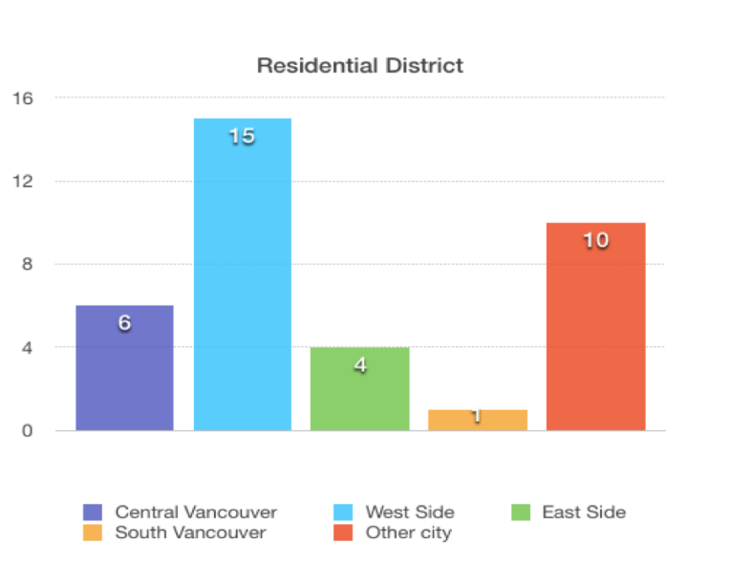

Figure 1.2 Average usage of paper cups per week per person
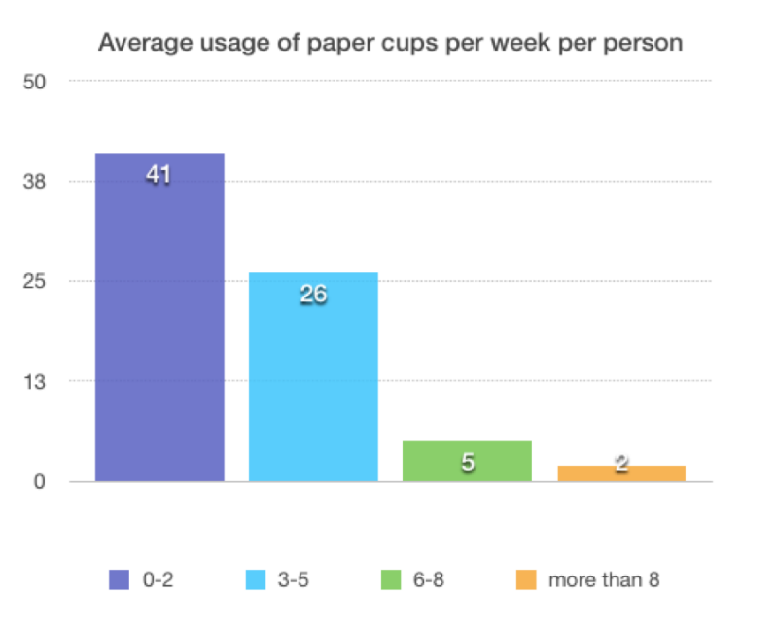

Figure 1.3 Testing the effectiveness of our video on paper cups reduction behavior
- Does this video influence on you?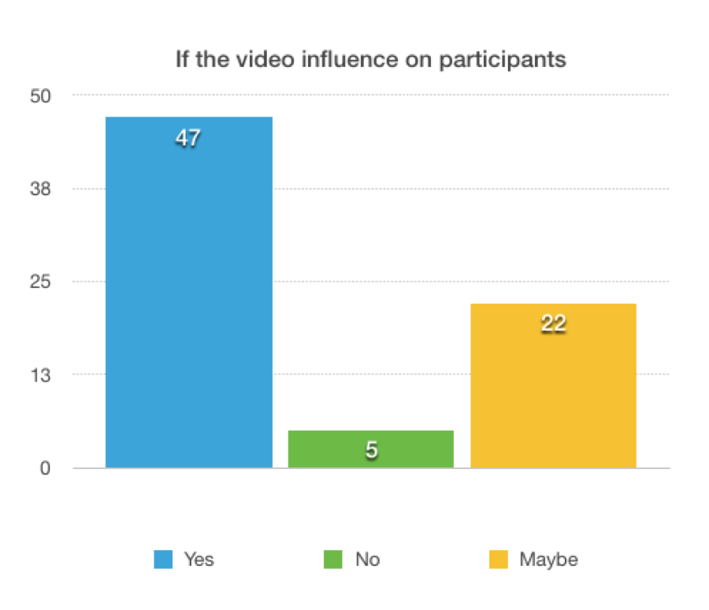
- Will you consider use less paper cups?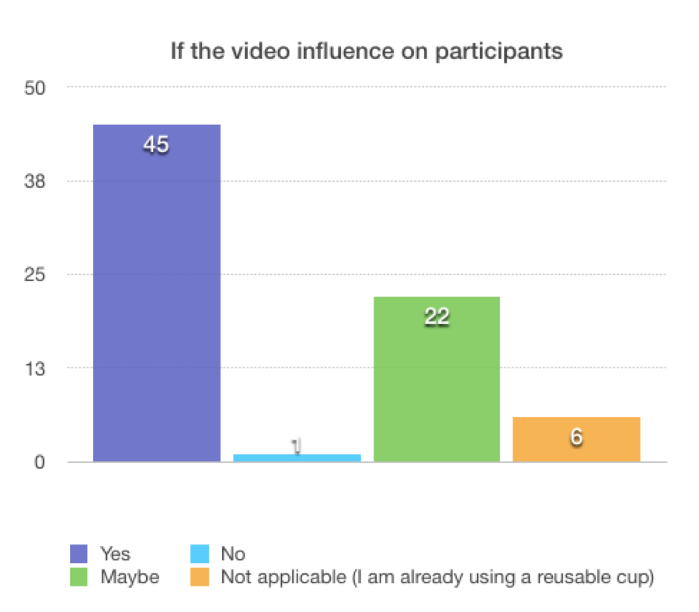

- Will you consider use a reusable cup?
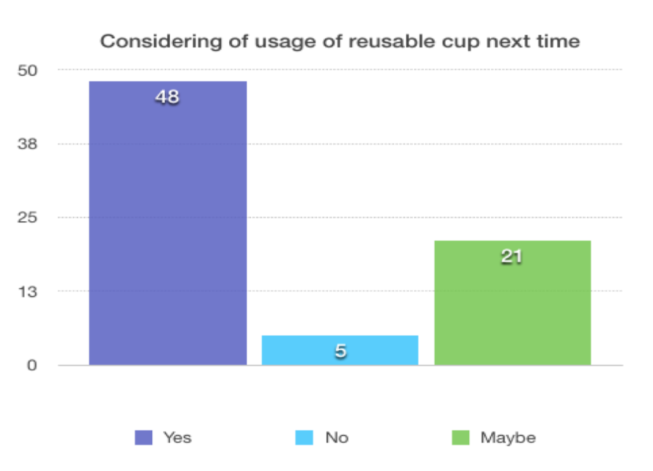

Figure 2. What would make you change your behaviors around the usage of paper cups?
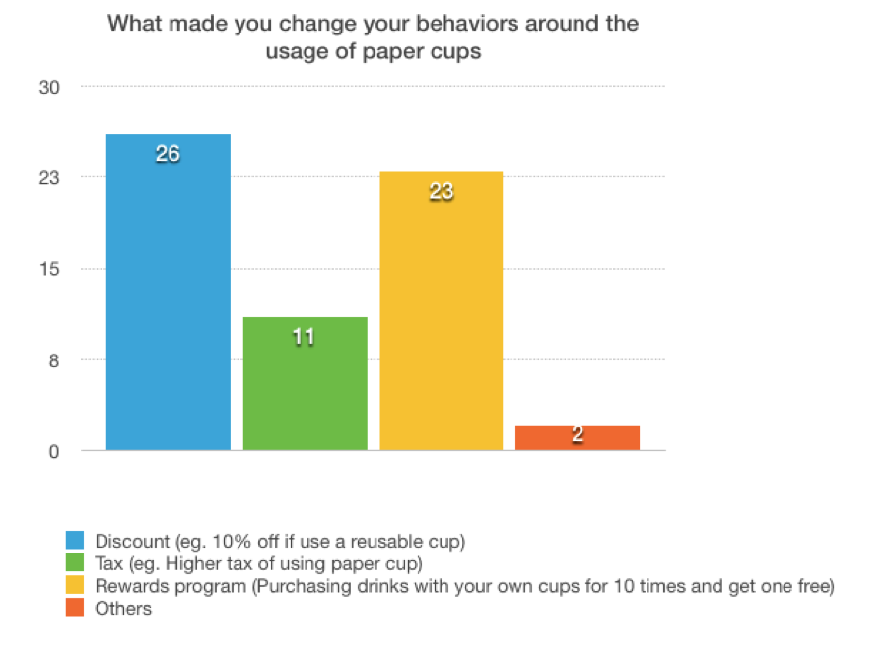
A-1. Other Comments on what strategies will make you change your behaviors around the usage of paper cups?
(1) Bring back the paper cups will get some discount
(2) Show people the usage of cups at the coffee place
(3) Extra charge for paper cups
(4) Offer less paper cups
(5) Provide "for here" cups for stay- drink- and then go.
(7) If they are not so available to get at the stores
(8) A social media challenge within the school community to increase accountability and inject an element of fun
(9) Return reusable cup to store so they can wash and use it again, so I don't have to carry mine around all day
(10) Having a reusable container rental/return system. Pay an in-store deposit, and return your reusable container on your next visit so it can be sanitized and replaced.
B-1. Pie chart for will you consider using less paper cups
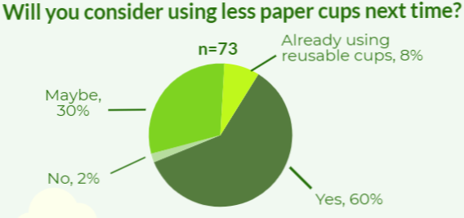

B-2. Pie chart for motivation for reducing the usage of paper cups
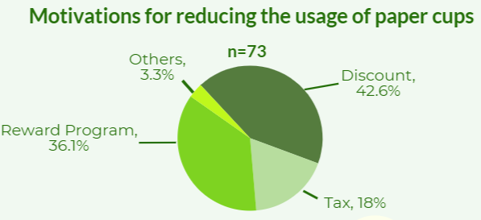
C-1. Final survey
- What is your age
  - Under 14
  - 15-24
  - 25-44
  - 44-64
  - 65-74
  - Above 74
- Which part of Vancouver do you live in?
  - Central Vancouver
  - West Side
  - East Side
  - South Vancouver
  - Other city
- On average, how many hot beverage single use paper cups do you consume weekly?
  - 0-2
  - 3-5
  - 6-8
  - Moore than 8
- After watching this video, does it influence you?
  - Yes
  - No
  - Maybe
- Will you consider using less single use paper cups?
  - Yes
  - No
  - Maybe
  - I am already using reusable cup
- Will you consider using a reusable cup next time?
  - Yes
  - No
  - Maybe
- What would make you change your behaviors around usage of paper cups?
  - Discount
  - Tax
  - Rewards program
  - Others
- What other strategies will make you change your behavior around the usage of paper cups? (optional)
- Email address for purpose of contacting you if you wind the cup (optional)

References
Brown, L. R. (2012). Full planet, empty plates: The new geopolitics of food scarcity (First ed.). New York: W.W. Norton & Company.

CityStudio. (n.d). What We Do. Retrieved from http://citystudiovancouver.com/what-we-do/

City of Vancouver. (2017). Creating a Single-Use Item Reduction Strategy- For Disposable Cups, Take-Out Containers and Shopping Bags. Retrieved from City of Vancouver website: http://vancouver.ca/files/cov/single-use-consultation-paper-9-12-2017.pdf

City of Vancouver (2017). Zero Waste Vancouver. Retrieved from http://vancouver.ca/green-vancouver/zero-waste-vancouver.aspx

Eisted, R., Larsen, A. W., & Christensen, T. H. (2009). Collection, transfer and transport of
waste: Accounting of greenhouse gases and global warming contribution.
Waste Management & Research, 27(8), 738-745. doi:10.1177/0734242X09347796

Fisher, K. (2006). Impact of Energy from Waste and Recycling Policy on UK
Greenhouse Gas Emissions – Final Report. Retrieved from randd.defra.gov.uk/Document.aspx?Document=WR0609_5737_FRP.pdf

Gottlieb, R., & Joshi, A. (2010). Food Justice. MIT Press.
Hertwig, R., & Pleskac, T. J. (2010). Decisions from experience: Why small samples?Cognition, 115(2), 225-237. doi:10.1016/j.cognition.2009.12.009

Sapsford, R. (2007). Survey research. London, CA: Sage Publications.

Waskey, A. (2011). Landfill methane. In D. Mulvaney & P. Robbins (Eds.), Green energy: An A-to-Z guide (pp. 275-277). Thousand Oaks, CA: SAGE Publications Ltd. doi: 10.4135/9781412971850.n81

