LFS 350 CBEL Project Final Report:
Richmond Food Asset Map

Group 15:
- Jacqueline Clark
- Kelly Huang
- Sansan Tan
- Selena Chiang
- Sherry Qin
- Kun Yu
Turnitin ID: 889342526

Introduction
The overriding goal of this project was to improve community food security¹ by developing a “food asset map”² for the city of Richmond which would assist residents in locating food assets in their community.. The framework of the recently established and well-recieved Vancouver Food Asset Map (VFAM) (VCH, 2017; Correira, C., 2017) was adopted to start the process in Richmond, in partnership with Vancouver Community Health (VCH). The broad commitment of VCH to “support(ing) healthy lives in healthy communities” led to its more specific food security goal of ensuring “all community residents obtain a safe, personally acceptable nutritious diet… (with)...community self reliance and equal access for everyone” (Hamm, M., & Bellows, A., 2013). Over 70% of Richmond’s population identifies as a visible minority (Statistics Canada, 2016) which creates unique challenges for the Richmond community to address issues around food insecurity due to language barriers, lack of financial/social support, and acculturation difficulties that may be faced by newer Canadians. In addition, over 38% of its population have an annual income of less than $40,000 and the child poverty rate, at 25%, is above the provincial average. The Richmond Food Bank feeds over 2200 people each week, 32% of whom are children (Richmond Food Bank, 2017). It is within this context that we aimed to work towards food justice as “community mapping process(es)” are intended to “promote social cohesion and reduce inequities by building connections… between local food sources and consumers”. (McCullum et al., 2005). Richmond had existing food assets and it was our intention to build an inventory of those assets, as part of an asset-based community development approach³,by developing a publically accessible, current, dynamic and easy to use online mapping tool. Since our focus was on food insecurity and vulnerable populations, the first two categories chosen for our map were free/subsidized meals and free/low cost groceries. Within these parameters, our objectives were:
- To update currently available information (provided by VCH and found online) and to acquire new, accurate information about additional organizations.
- To facilitate instructional sessions on the use of the map and gather feedback from community representatives selected by VCH.
- To compile a report, summarizing the feedback collected with reference to the overall map and the two assigned categories.

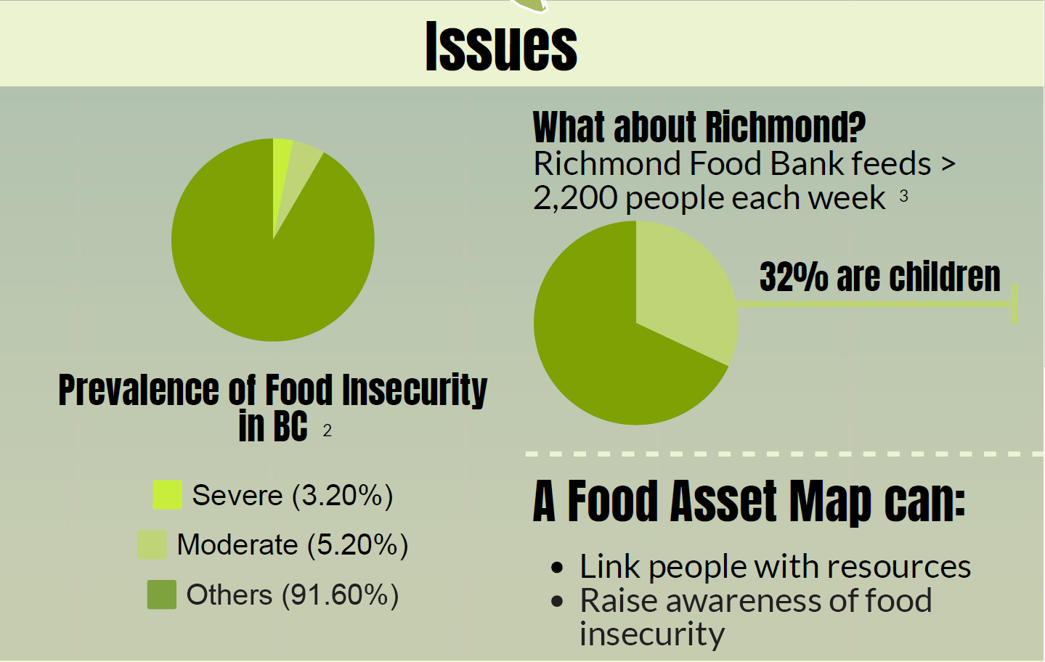
Figure 1. Issues of food insecurity in Richmond (from final infographic poster)

Methods
Data Collection Approach
In the first step of this project (objective 1), 10 organizations that provide free or low-cost meals or grocery items were identified either through online search engines or from a brochure made available by (VCH) dietitian, Anne Swann. Requests for participation in the RFAM project were sent by email to all organizations along with the detailed description of this RFAM project in lay language; an excel spreadsheet to fill out essential information for RFAM (Appendix C; Fig. C-1); a link to the VFAM; instructions for its use and a glossary of terms used in the map. Information collected included: the location, service hours, phone number, email of the organization; the type, cost of meal/groceries; and population served, including how to receive the service. All data collected was entered into excel spreadsheets for each category then used by VCH, after their approval, to create a trial RFAM (link in Appendix C)

Analysis
Data analysis and an evaluation of the usefulness of the trial RFAM took place in the second part of the approach (objective 2). Eight community members who worked with vulnerable populations or in social service organizations in Richmond were identified by the VCH dietitians and invited, by email, to review the map. In the initial invitation, a link to the map; instructions; glossary; a consent form⁵; and an evaluation form (see Appendix Fig C-2) were sent to participants. Interviews were to be conducted in person, and comprised of a demonstration of how to use the map, recording responses to the standard evaluation questions and encouraging participants to share additional comments about the RFAM. All completed evaluation forms and comments were summarized and sent to VCH, our community partners in this project. (Evaluation summary, Appendix D)

Ethical considerations
All 6 UBC group members completed the second edition of the Tri-Council Policy Statement: Ethical Conduct of Research Involving Humans Course⁶ before conducting any field studies. In the first step of the project, email or verbal permission was granted from all organizations before their information was added to the trial RFAM. In the second phase, UBC consent forms ⁵ were completed by all community members who took part in the evaluation process. Additionally, all participants were notified that all information they provided would be kept anonymous, only accessible by partners or students who are involved in this project, and that none of information would be published.

Results
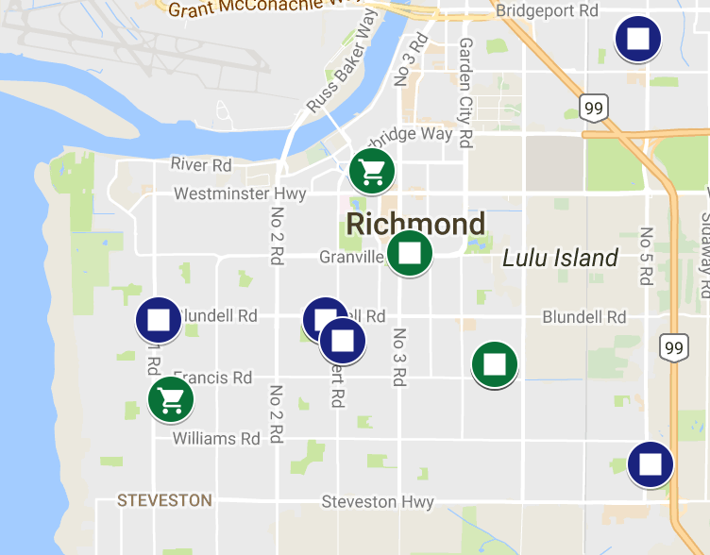
Figure 2. Existing free/low cost meal and grocery items on Richmond Food Asset Map
After phase one, 9 out of the 10 organizations providing free/low cost meals/grocery items agreed to have the requested information added to the RFAM and available to the public. The organizations provided a total of 14 assets (10 free subsidized meals; 4 free/low cost groceries) as some organizations filled roles in both categories. The information was uploaded by Anne Swan and Rani Wangsawidjaya of VCH onto a single google map platform. This completed our first objective and helped support the goal of improved community food access.

In phase two, 8 community partners were contacted via email. Two community partners were not available after repeated attempts, five agreed to the interviews, and one sent a completed, detailed evaluation by email , bringing the total to six. Although such a small sample cannot represent the whole Richmond community, the face to face interviews gave us valuable feedback on the map and thoughtful insights into the community. Several interviewees suggested that map categories should be more specific (e.g. the difference between ‘food literacy’ and ‘food safe’ skills is substantial, targeting different populations, but both are included in the “Food Skills” category): descriptions could be more precise; and important information prioritized/highlighted. Every community has unique demographics and recommendations were made to adapt the RFAM to better suit the community in ways such as adding a “translation” button to accommodate the several languages spoken in Richmond. However, all interviewees responded confidently that they would use the asset map in the future and considered it necessary, user friendly and interactive. A comprehensive summary of the evaluations was sent to the VCH dietitians (see Appendix D).
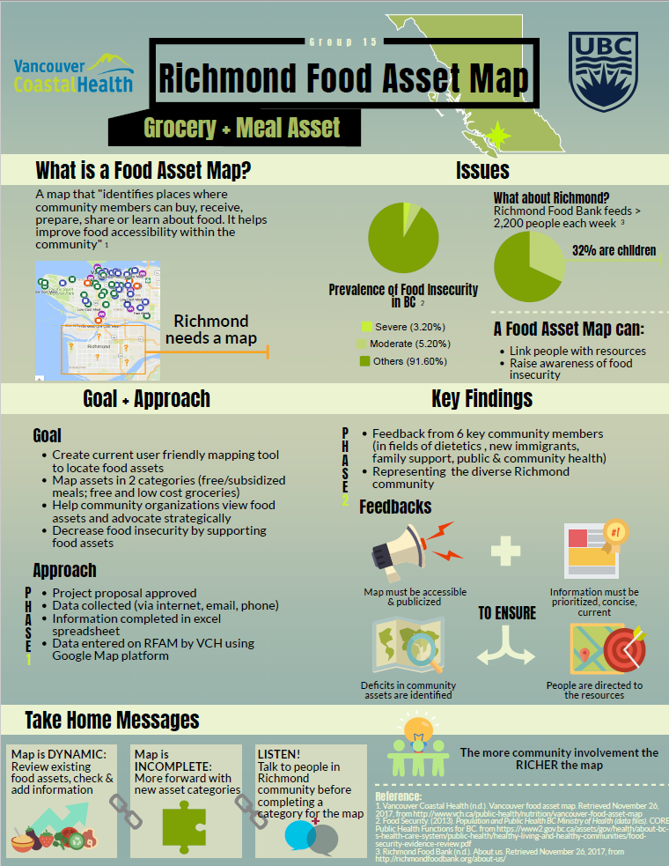
Figure 3: Infographic of RFAM project

Discussion

In evaluating the effectiveness of the project, we must consider whether it succeeded in its overall goal of reducing food insecurity and increasing “food justice”⁷ in the Richmond community. Although the project was not part of an official overall strategy of improving community food security in Richmond, it is conceivable that, even as a standalone measure, it will play a part in alleviating some food access issues that exist there. As a new project, there was some uncertainty to how a food asset map might be used and by whom which was not resolved as our task began. Preconceived ideas that it would be used by individuals only raised concerns about the vulnerable sectors of the population, whose needs we wanted to address (homeless, shut-ins), and who may not have the resources or technical knowledge to benefit from the map. However, as the project took shape, the food assets mapped, and the trial map evaluated, it became clear that many map users would be proxies for large numbers of clients from diverse groups. These community representatives would disseminate information from the map, tailored to suit the specific needs of their clients. Much thought was given by community members as to how best to publicize the RFAM as it was recognized that the map can only benefit people and adapt the changes in the community, if it is widely available. Ideas such as informing schools for their newsletters and making the map available on computers at public libraries came from interviewees who saw the RFAM as a valuable tool and were enthusiastic about sharing their knowledge.

It was evident to us that every community is unique and Richmond was no exception. With 60% of its residents self-identifying as immigrants (Population and Demographics, 2011) with diverse cultures and languages, adaptations may have to be made to the RFAM. According to Health Canada (2012), immigrants have a significantly higher prevalence of food insecurity (12.6%) compared to non-immigrant Canadians (7.5%) ( Health Canada, 2012). Furthermore, many immigrants have difficulty grocery shopping and identifying new foods (Moffat et al., 2017). To reduce language barriers and encourage use of the map, a translation button was suggested as well as the inclusion of transit information close to each food asset location. Cooking classes in different languages were identified by interviewees as a possible solution to issues around lack of knowledge of local foods and how to cook with unfamiliar foods which have been reported by Richmond Food Security Society & Centre for Sustainable Food Systems at UBC (Intercultural Food Security Study, 2017).

There were several limitations of the methods used. The relatively short time span of the project meant that the group was less familiar with Richmond than would have been ideal, thus potentially missed mapping some assets. The lengthy wording of emails with several attachments caused difficulties for our participants, some of whom who did not immediately understand what was required of them, delaying their response times. The choice of in-person interviews as compared to a simple “yes-no” survey necessitated a small sample size which meant our data could not reasonably be reported in quantitative terms. However, the detailed feedback we received from community members who were knowledgeable in the local food system provided us with extremely valuable, qualitative data. Modifications could be made to the design by simplifying emails sent out to community members (bullet points); increasing the amount of time allocated to phase 2 to accommodate the schedules of interviewers and interviewees, potentially increasing the number of responses; offering other options for respondents for their convenience such as including some shorter questionnaires to be returned by email; and offering longer interviews in a phone call or skype format as well as in person.

Conclusion
In conclusion, we succeeded in establishing a food asset map for Richmond, which is a brand-new tool with the potential of assisting with community food security issues. Evaluation interviews of community members garnered many positive comments as well as useful insights into the community and possible adaptations of the RFAM. All participants expressed the desire to use it, expand it and ensure it was available in the community. As mentioned previously, Vancouver has food asset map and the inclusion of Richmond in the mapping process adds to community knowledge of our food system. While we completed our specific objectives, one question remains unanswered. We do not yet know how well our mapping tool will work once it is released to the public and how effective it will be in benefiting the more vulnerable sectors of the population. Currently, the RFAM map includes four food asset categories: free/low meals and groceries, open kitchens and food skills programs.. From here, future project participants should make adjustments so that categories and map design itself fits the community’s needs better. In addition, current assets on the map should be reviewed and revisited regularly to make sure the information is up-to-date and new categories added to mirror the VFAM. We look forward to the point at which our map is publicly available.
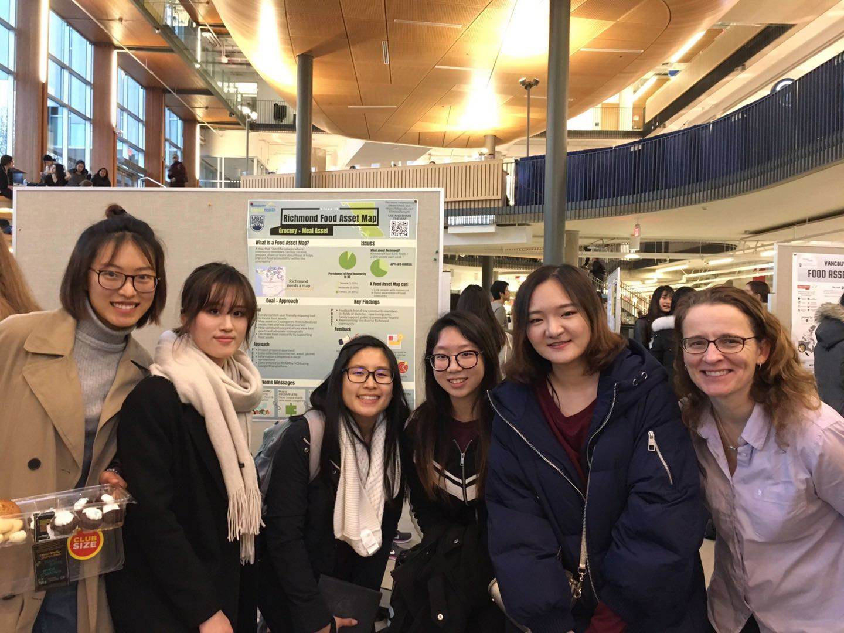
Figure 4: Group photo on presenting day

Appendix A
Critical Reflections
- Student 1:
Food injustice has already been a big consideration that arises in public nowadays. Different from the food security, food justice is more focusing on the equal rights for each person to get adequate and nutritious food. Food injustice is the problem of disproportionate access of healthy food experienced by low-income communities, environmental barrier, and race of communities (Hayes & Carbone, 2015). Before getting into the community-based project, I did not consider food injustice as a significant concern in our society. However, when I was doing the RFAM project, I did some research on the background information of our community, and I found things are not as simple as I thought. Canada is a multicultural country, it is is great place to welcome people from everywhere in the world. But when comes to the living quality of new immigrants, food injustice is happening. Unlike Canadian-born residents, immigrants have less access of adequate healthy food due to culture barriers, low income and weak social networks. Richmond is a minority dominated city, more people, especially immigrants, are living in food insecurity. For example, due to the language barrier, many Chinese senior people go to very limited places to find food, most are Chinese stores. But most of food in Chinese supermarket are in higher prices compared to the local stores, even in the same quality. Hence, in terms of food justice, the gap is significant happening among residents with different cultures. We hope by building up the food asset map, everyone in the community can have access to these free or low cost nutritious foods, and food justice issue can be improved.
- Student 2
Overall, LFS 350 is a unique course with a contemporary approach to teaching and learning about food system and food justice. Moreover, it has changed my understanding of food justice issue within a community. Living in an environment surrounded by excessed amount of food and people who have never experienced hunger and poverty, I never thought lack of food justice is a prevalent issue in communities in Canada. Through talking to the community partners in the RFAM project, I realized even though Richmond is well-known for its diverse food culture, food insecurity issue persists in the community. Understanding the food security problems in the Richmond community gave me motivations to work on the RFAM project and make contribution to the community I currently live in. However, as the project proceed, I started to question the usefulness of the RFAM. The RFAM does improve the accessibility of food, but does it enhance the overall food justice in the community? The city of Richmond consists of high proportion of visible minority. How does this map address racial equity in the food? Through the process of hands-on experience, I understood that food justice is not a one dimensional problem. Although small steps have to be taken before making a big improvement within a community, the food justice issue should be addressed in a systematic way.
- Student 3
To be honest, during the beginning of the course, I literally had no idea of what does food justice mean. Last year in LFS 250, we have covered food security and food sovereignty, but food justice was a pretty new concept for me. “Justice” is much more like a word that used in judicial occasions instead of used to describe food. Throughout the learning in this term, now I have an integral concept about food justice. To achieve food justice, disparities and inequities in food system must be eliminated to make sure that everyone has the right to access good food. For example, gender discrimination is a common issue in some regions where food is inadequate to meet the high demand. Women usually don’t have as much power as men do when competing for foods, which leads to food injustice among women populations.
To address the goal of improving food injustice and insecurity in Richmond, we set up a Community Based Experiential Learning project and developed a Richmond Food Asset map which locates the free/low-cost meal and groceries, open kitchens and food literacy workshops in Richmond. We hope the map can help those low socioeconomic status populations to get more access to food and increase their choices of food, and some community organizations invited to evaluate our project all give positive comments.
By taking this course and doing the CBEL project, I’ve developed knowledge about food justice and enhanced my understanding about food security and sovereignty, which is a huge benefit for me and helps me to have a better understanding of the overall food system.
- Student 4
When I was first introduced to the concept of “food justice” in the beginning of the course, I thought about fair distribution of food among people and across diverse ethnicities and it was close to the real definition; however, I did not know how to achieve this equal access to food.This was where our project come into play. Our group worked on the Richmond Food Asset map in order to build the connection between resources and the local community members. I acknowledged that I overlooked the project as only the tool to locate access to subsidies before we begin the project. Even though access to food is an important aspect of food security, it does not really support mediating disparities and inequities which is the fundamental goal of food justice. But, community development, in fact, is a gradual process, and the further we worked on the project and received detailed feedback, I realized the potential of the map -- it actually is a powerful tool to support asset-based community development. By locating different resources, the map enables the community to realize the resources that already exist within the community and the resources they are lacking and seeking for. They would therefore appreciate the existing institutions and build on from there. For instance, the may shows several food bank locations in the city that provide free meals, but lacks information on low cost grocery stores. Perhaps they do exist, but they may not be well known as the large organization, like food bank. So, the map shows potential for bridging this gap between local knowledge and our project and seek a way for community engagement by allowing them to have an overall view of their own local food asset map. With positive attitude, I believe that, this project on the food asset map enables community members to learn about their community, and therefore have a say on improving and shaping their community leading to decreasing food injustice.
- Student 5
“Food Justice” … at the start of the course, I would have said that I had a good idea of what it might mean. It related to food and some type of equity, so I considered it closely related to “food security” as defined by the FAO (FAO, 1996). After all the “justice” must refer to everyone have an equal right to culturally appropriate food and involve fairness and sharing. Throughout the course, I began to see the concept as much broader, encompassing many aspects of the food system including food supply, food sovereignty, the rights of those employed in food industries (social justice), just sustainability, and not simply an individual’s ability to access food. As the semester continued, “food justice” became more complex and many grey areas emerged. Issues of race, ethnicity, and gender factored into any individual’s ability to access food, it wasn’t a simple issue. Finally, the discussions on indigenous food sovereignty and power and privilege forever changed my perspective as I saw that injustice ran deep within our society. Injustice related to the food system is not isolated but a reflection of our history, culture and values which have shaped many aspects of the world we take for granted. In the community project, I wanted to look deeper than simply what food assets excised for mapping. As I talked to members of the community, I wondered about the layers of knowledge that existed beneath the surface and the “regulated”, the alternative ways of meeting needs of different cultures, the unrecognized food networks, and support systems. There may be more complex, underlying reasons for the statistics on food insecurity or child poverty in Richmond, not just those, such as low income, that are immediately apparent. I realized that although I had only scratched the surface, the learning I experienced had made me stop to question my own assumptions about the causes of and solutions to any food security issue.
- Student 6
At the beginning of this course, the phrase “Food Justice” were on a single slide of a power point. With no knowledge of what food justice, I thought it as the right of people getting the food but did not think about the people getting enough nutritious food due to the income level. However, the true definition of food justice despite income level, all food should process, transport, distribute, consume justly within the population. The concept looks great but is this even possible to achieve in the modern society? Joining the CBEL project has taught me that everything is possible. RFAM act as a bridge between the community assets and the community. By pulling those together, the community is able to utilizes the assets to a greater good. I guess my perspective on food justice does not change but finally realize what is the meaning of food justice and how it can apply to our community. RFAM spotted and gathered the community assets and, furthermore, public the map into the community knowledge in order to increase food access. Food is what supports us and drives us to live our lives. People should not be strangled by food. RFAM aid in distributing the food in the concept of food justice at the moment, it will expand and update its horizon in every aspect. I look forward seeing RFAM flourish within the community in the future after it publicized.

Appendix B
Definitions
¹ Community food security: Community food security exists when all community residents obtain a safe, personally acceptable, nutritious diet through a sustainable food system that maximizes healthy choices, community self-reliance. (Hamm & Bellows 2003)
²Food asset: a place where people can grow, prepare, share, buy, receive or learn about food. Community organizations and schools are included because they are places where community members. (Vancouver Coastal Health, 2017)
³Asset based community development: methodology for the sustainable development of communities based on their strengths and potentials. It involves assessing the resources, skills, and experience available in a community; organizing the community around issues that move its members into action; and then determining and taking appropriate action. (Kretzmann & McKnight, 1996)
⁴Community Meals and Food Banks in Richmond (Richmond Public Health)
⁵LFS 350 Consent Form (https://canvas.ubc.ca/courses/1209/files?preview=266609, 2017)
⁶TCPS2: Ethical Guidelines Regulations. (n.d.). Retrieved December 03, 2017, from https://humansubjects.nih.gov/ethical-guidelines-regulations
⁷Food justice: Food justice seeks to ensure that the benefits and risks of where, what and how food is grown, produced, transported, distributed, accessed and eaten are shared fairly. (Food justice, 2016)

Appendix C:
The link to the Trail RFAM: https://drive.google.com/open?id=10Pc_lJ_yoytHv5ME63NnXhdRDOA&usp=sharing
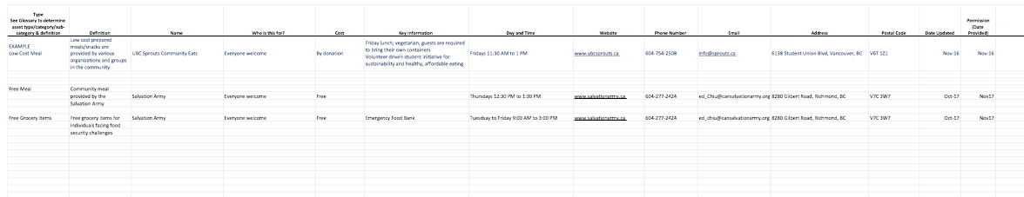Figure C-1. Excel Spreadsheet for Data Collection in the First Step Approach

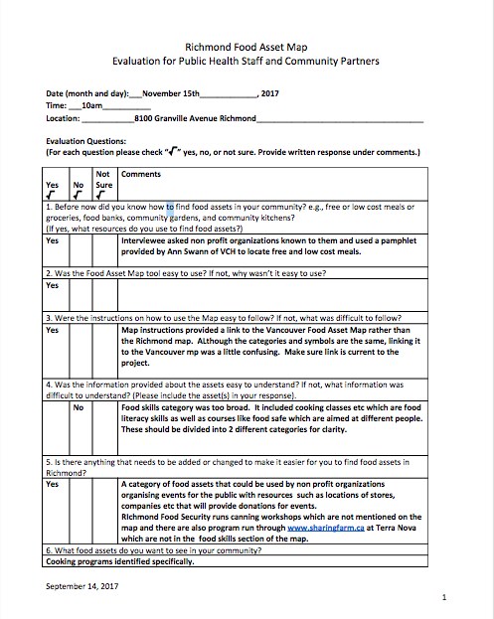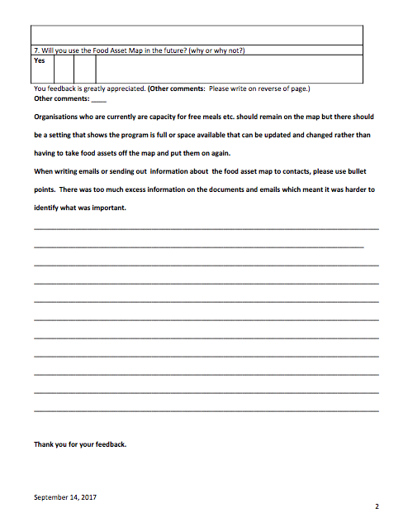
Figure C-2. Evaluation Form Used in the Second Step of Approach

Appendix D
RFAM Evaluation Summary November 21, 2017

A total of 6 evaluations were carried out (five in person and one by email, at the interviewee’s request) from a list of 8 contacts provided by VCH. All interviews were conducted between November 10th-20th, 2017 with all in person interviews conducted in Richmond. UBC consent forms were signed by all participants. Despite repeated attempts at scheduling, rescheduling due to interviewee commitments, and offers of phone interviews, the last 2 evaluations could not be completed.

Note: number in brackets after each comment e.g. (2) reflects the number of interviewees who made this comment i.e. 2 respondents made the comment.

- Current knowledge of how to find food assets
- 5 out of 6 respondents did know how to find food assets; 1 did not.
Current resources:
- Word of mouth /connections in place of work (2)
- Online: Affordable Food In Richmond Map (Richmond Food Security Society); Richmond Poverty Response Committee; BC211; information from colleges (2)
- Professional partnerships with organizations that provide links to resources (1)
- “Community Meals and Food Banks in Richmond” pamphlet (1)
- Food asset has a high profile in community eg Food Bank (1)
- City of Richmond monthly community meetings (1)

2. Using/Navigating the map
- 6 out of 6 respondents did find the map easy to use.
- Helpful that map is based on google platform (1)

3. Instructions provided on using the map
- 4 out of 6 respondents did find the instructions easy to understand; 2 did not.

- Clear/easy to follow (2)
- Informative for people not familiar with google (1)
- Too lengthy (takes >30 minutes) and complicated for seniors (1)
- Video preferable to written instructions (1)
- Instructions unnecessary (1)
- Link provided should have been current (Linking the VFAM and not the RFAM is confusing although icons are identical) (1)
- Technical problems (unable to click on icons prior to instructional interview) (1)

4. Food asset information provided
- 5 out of 6 respondents did find the food asset information easy to understand; 1 did not.
Asset Categories
- Some asset categories too broad and should be divided (3)
- Food Skills category: encompasses 2 very separate types of asset (cooking class/food literacy type and food safe/accreditation type) which are aimed at different populations. Should be divided into 2 food asset categories (2)
- Category icons: most not intuitively or easily understood (except grocery cart); glossary was required (2)
Layout/Links/Spelling
- Pertinent information about food asset should appear directly under its name eg time, location, price, key information. Currently, “defintion” is below food asset name which is less important for users and means unnecessary reading to find the information required. Move definition down and details of programme up (1)
- Links: Some links (Thompson Community Centre, Steveston Community Centre) do not lead to programme information; Richmond Foodbank link is not a hyperlink (1)
- Spelling: incorrect spelling of Steveston (“Stetson”) (1)

5. Additions/changes to the RFAM
- 4 of 6 respondents did think changes to the map were needed; 1 did not;1 was unsure
Additional Asset Categories
- Cooking programmes as a separate category (2)
- Low cost groceries category (1)
- Community gardens category(1)
- “Community donor” category: a list and locations of companies, stores etc. that will provide donations for community events that could be used by non profit organizations who are organizing events for the public (1)
Additional Assets
- Affordable Food in Richmond Map (2)
https://www.google.com/maps/d/viewer?mid=1-zwRx57_jEN-iZ5qLpQpCGf7S6E&ll=49.16345843027532%2C-123.0986557&z=13
- Richmond Poverty Response Committee (1) https://www.richmondprc.org/about-us/
- BC 211 (1) http://www.bc211.ca/
- Canning workshops run by Richmond Food Security Society (1) (Food Skills)
- Programmes run through www.sharingfarm.ca at Terra Nova (1) (Food Skills)

6. Food assets wanted in the Richmond community
- More free or lost cost groceries, especially fresh foods (3)
- More community gardens (2)
- System of channelling food from factories or community gardens to schools so students can have access to those foods (1)
- More food donations to schools (1)
- More breakfast clubs (1)
- More farmers’ markets (1)
- More cooking programmes in additional languages (1)

7. Future Use of RFAM
- 6 out of 6 will use the map in the future
- Will use with clients (including low income/SES, newer Canadians, refugees, teachers and counsellors) (3)
- User friendly/interactive (2)
- Should be promoted through school newsletters to inform general public (1)
- Printed copies useful for those not familiar with technology (1)

8. Additional comments
- Regularly updating the map is essential to its success (2)
- Purpose of the map should be more clearly defined. Unclear how the map and the team “food asset” is connected to “food security” (1)
- Some clients may encounter problems navigating the map due to language barriers if English is not their first language (1)
- New shelter coming at Horseshoe way on the land beside Garden CIty Road will be part of Richmond food security food assets in the future (1)
- Ensuring that people are aware of and can find the map is crucial (1)

9. Additional Recommendations
- Recommendation to add a nearby skytrain station/bus route information in different languages in scroll down menu at asset location information. (1)
- Recommendation to add information on whether cooking classes require registration and if cost is per person/per family. (1)
- Recommendation that organisations who are currently are capacity for free meals etc. should remain on the map but there should be a setting that shows that the program is full or that space available that can be updated and changed rather than having to take food assets off the map and put them on again (1)
- Recommendation that when writing emails or sending out information about the food asset map to contacts, use bullet points. Too much excess information on the documents and emails mean it is harder to identify what was important. (1)

References
Correia, C. (2017, October 17). Vancouver map helps hungry people find healthy, low-cost food. Retrieved October 20, 2017, from http://www.cbc.ca/news/canada/british-columbia/vancouver-food-asset-map-1.4357392
Canada, G. O. (2016, November 23). NHS Profile, 2011. Retrieved September 29, 2017, from http://www12.statcan.gc.ca/nhs-enm/2011/dp-pd/prof/index.cfm?Lang=E
Canada, H. (2012, July 25). Household Food Insecurity in Canada: Overview. Retrieved December 02, 2017, from https://www.canada.ca/en/health-canada/services/food-nutrition/food-nutrition-surveillance/health-nutrition-surveys/canadian-community-health-survey-cchs/household-food-insecurity-canada-overview.html
Food Justice. (2016, December 22). Retrieved December 03, 2017, from https://foodsecurecanada.org/community-networks/food-justice
Food security statistics. (n.d.). Retrieved December 03, 2017, from http://www.fao.org/economic/ess/ess-fs/en/
Hamm, M. W., & Bellows, A. C. (2003). Community Food Security and Nutrition Educators. Journal of Nutrition Education and Behavior, 35(1), 37-43. doi:10.1016/s1499-4046(06)60325-4
Intercultural Food Security Study. (n.d.). Retrieved December 02, 2017, from https://www.richmondfoodsecurity.org/research-and-advocacy/intercultural-food-security-study/
Kretzmann, J., & Mcknight, J. P. (1996). Assets-based community development. National Civic Review, 85(4), 23-29. doi:10.1002/ncr.4100850405
Mccullum, C., Desjardins, E., Kraak, V. I., Ladipo, P., & Costello, H. (2005). Evidence-based strategies to build community food security. Journal of the American Dietetic Association, 105(2), 278-283. doi:10.1016/j.jada.2004.12.015
Moffat, T., Mohammed, C., & Newbold, K. B. (2017). Cultural Dimensions of Food Insecurity among Immigrants and Refugees. Human Organization, 76(1), 15-27. doi:10.17730/0018-7259.76.1.15
Population and Demographics. (n.d.). Retrieved December 02, 2017, from https://www.richmond.ca/discover/about/demographics.htm
Vancouver Coastal Health. (n.d.). Retrieved October 08, 2017, from http://www.vch.ca/

