Final Community Project Report
Hastings-Sunrise Community Food Network - Community Food Circles Food Literacy Workshops

LFS 350 Group 12 - December 3, 2017

Introduction
Background & Context
Following LFS 350 Fall 2017 Group 22’s project, our group continues working on the Community Food Circles (CFC) project in partnership with the Hastings-Sunrise Community Food Network (HSCFN). This project addresses community food security and how community food programs can further increase access to healthy and affordable food. HSCFN, a non-profit organization, includes Thunderbird Community Centre, Hastings Community Centre, Kiwassa Neighbourhood House, Frog Hollow Neighbourhood House, and City Reach. The CFC project strives to enhance food security and build a just, sustainable, and resilient food system in the Hastings-Sunrise community (HSCFN, 2015). Located in East Vancouver, the community consists primarily of 41.8% English-speaking and 35.4% Chinese-speaking residents (Statistics Canada, Census, 2011). The median income in East Vancouver was $54,376 in 2015, however 22.2% of households are reported to be low income with 25.8% being 65 years old or older (Statistics Canada, Census, 2016).

Significance
Community food programs can enhance food security, which occurs “if all people at all times have physical, social, and economic access to sufficient, safe, and nutritious food that meets their dietary needs and food preferences for an active and healthy life” (Upton, Cisse & Barrett, 2016). These programs support food security by providing various resources to reduce food costs, improve quality of food, and increase access (McIntyre, 1999). Resources include community kitchens, gardens, and food bag programs, all of which HSCFN provides. Miewald and Ostry (2014) mention, “Food-related programs including gardens and communal kitchens may be strategies to increase food access for residents, to utilize communal spaces for social benefit as well as crime reduction”. Therefore, community-level initiatives are fairly successful in providing food sources for individuals who need it, and can be beneficial to low-income households with unavailable or inadequate growing and cooking facilities (Miewald & Ostry, 2014).

Objectives
Our project in collaboration with HSCFN during their Year 2 of the CFC project aims to increase community capacity in food security, specifically increasing access to healthy and affordable food by enhancing food literacy. Our objectives include developing accessible resources to contribute to food literacy through a social media platform (Instagram), and attending a Food Bank Cooking Challenge (FBCC). From this a Food Skills Guide will be created. HSCFN concluded from focus groups in Year 1 that recipients of community food programs, including food banks, do not know how to use all the food they receive thus reducing their food access (J. MacKinnon, personal communication, October 23, 2017). Therefore, our approach addresses food skills and knowledge, including skills and practices that help individuals navigate, engage, and participate within a complex food system (Cullen, Hatch, Martin, Higgins & Sheppard, 2015). Through this project, our group expects to be better informed on the challenges community members face in regards to using and accessing healthy food. Moreover, we hope the Instagram helps increase awareness of healthy, affordable food options while the guide provides members with the potential of making satisfying, delicious, and diverse meals on a budget.

Inquiry
•How can we make a Food Skills Guide that accommodates the characteristics of the community?
•How can we use Instagram to increase awareness of low-cost food options?

Methods
Data Collection
Quantitative data was collected through visits to grocers while taking pictures of low-cost produce bags to find the most frequent appearing produce. Pictures were taken six days a week from October 26th to November 21st. The grocers, located in Vancouver and Richmond, included T&T Supermarket, Kin’s Farm Market, Walmart, Famous Foods, and Donald’s Market. Other data came from discussions with a food insecure Hastings-Sunrise community member and a Thunderbird community member who leads community food programs. To learn what prevents food program recipients from using the food they receive, our group participated in a FBCC and was tasked with creating a meal using limited food items. Items were provided through a food box a community member was given from the food bank for that one week. Notes were taken during these meetings to be later analyzed.

Analysis
55 types of produce were analyzed through Microsoft Excel, and data was graphed to determine the distribution and variety of produce. Data was formatted into a clustered column graph to determine predominant food items, and a pie graph to analyze the food groups present. Furthermore, data from grocery store visits and discussions were analyzed to guide us in drafting the Food Skills Guide while taking into consideration community members’ insights.

Ethical Consideration
We attempted to adopt an Asset-Based Community Development approach where we focused on working in collaboration with the community and taking to heart the thoughts and insights of the members. Furthermore, pictures posted on Instagram were only of produce and not people; therefore, consent forms were not needed to protect people’s privacy.

Results
From visiting the low-cost produce section of the grocers, we found that the produce were relatively good in quality, but limited in quantity (Figure 1). There would usually be one shelf set aside for the bags with minimal labels for identification (Figure 1).

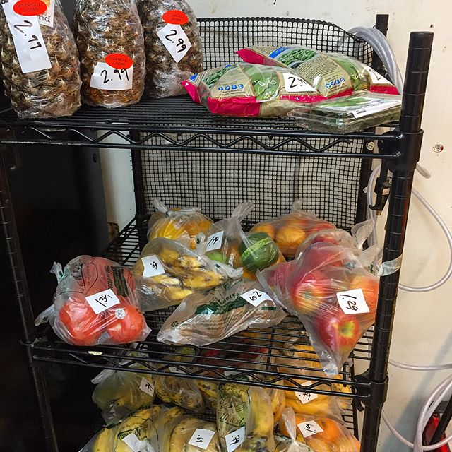
Figure 1. Photo of low cost produce bags found in Famous Foods on November 16, 2017.
The top five produce found were: apples, oranges, peppers, lettuce, and bananas (Figure 2). Therefore, low-cost produce bags may be a good source for accessing these types of produce. However, other produce typically appeared one to three times.
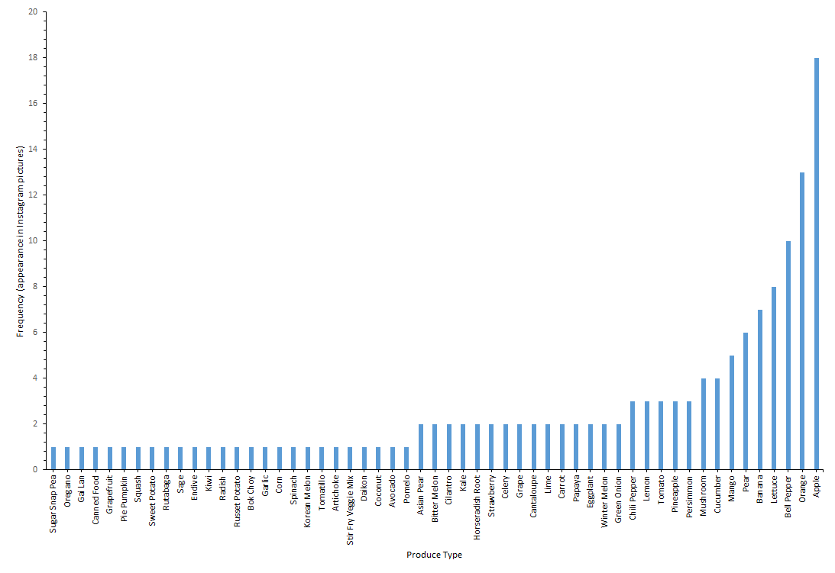
Figure 2. Frequency of appearance in Instagram pictures in relation to produce type. 55 produce types were found between October 26th and November 21st from 27 Instagram pictures collected from six grocers – T&T Supermarket, Kin’s Farm Market, Walmart, Famous Foods, and Donald’s Market.

Fruits comprised the majority of produce in the bags while protein and oils were absent (Figure 3). These two food groups were also absent in the food bank bag which is concerning because daily macronutrient requirements cannot be met by relying on low-cost produce bags and food bank bags alone.

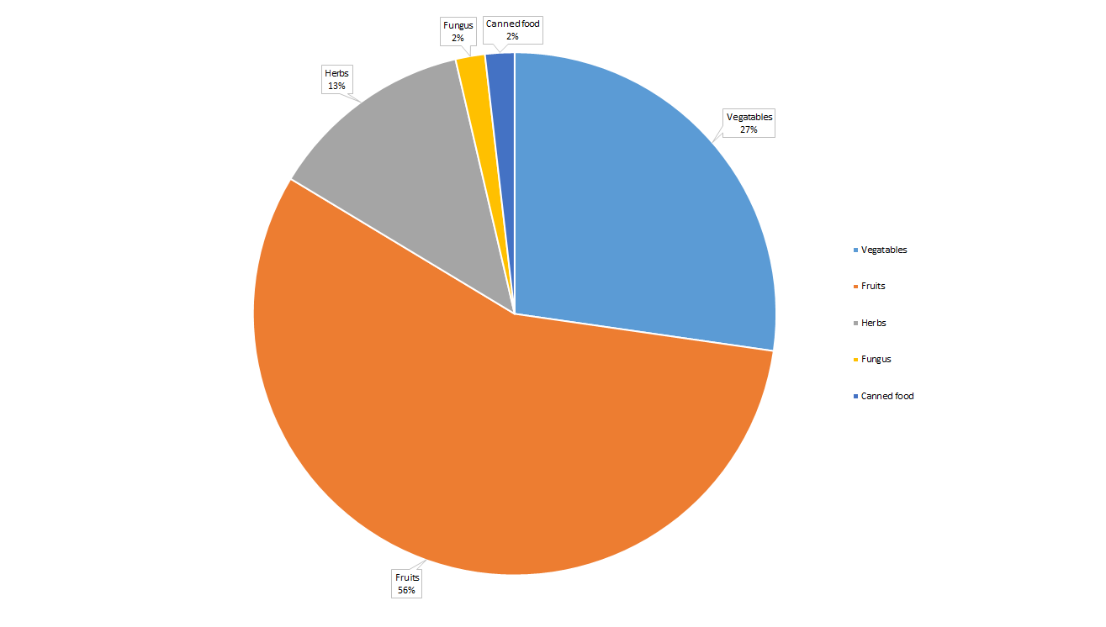
Figure 3. The percentage of each food group found in the low cost produce bags out of 55 produce types. Fruits and vegetables were categorized based on the botanical definition. The produce types were found in the Instagram pictures between October 26th and November 21st. 27 Instagram pictures were collected from six grocers – T&T Supermarket, Kin’s Farm Market, Walmart, Famous Foods, and Donald’s Market.

Participating in the FBCC allowed us to recognize the many barriers in using food provided by food programs. Flavourful and satisfying meals were difficult to make by using the food bank bag alone. There were also limited ingredients that did not span across all food groups, therefore, people would not be able to meet their adequate nutrient requirements.

Discussion
By participating in the FBCC, we learned how to cook using foods from a recipient’s food bag and received deeper understanding of barriers community members face. Through this, the process of creating the food guide focused on the awareness that community members know how to prepare food in general since food insecure individuals do not report having lower food preparation skills than food secure individuals (PROOF, 2017). Likewise, it is reported that there is little difference in cooking ability between food insecure and food secure people (PROOF, 2017). Rather than creating a resource full of recipes and instructions, the contents are of basic details about the identified food item and ways it can be used. It is up to the user to decide how they want to utilize the ingredient, which may encourage them and add confidence in their capabilities as they can make their own decision (Mathie & Cunningham, 2013).
When we talked with a food insecure community member, our initial views and impressions on the topic of food banks were questioned as she shared mainly negative experiences. Many of the food she received from the food banks were not of great nutritious value nor had great variety. Her experiences mirrored our findings from the FBCC and provided us with better understanding of challenges the food insecure, who depend on food banks, face. Therefore, with a platform that community members can access, like Instagram, or by increasing community food programs that increase awareness of cost effective food options, increases in access to healthy and affordable food can occur (McIntyre, 1999).
A limitation of our guide is its potential inaccessibility to community members who need it most. Using Instagram as a platform may restrict members who have limited access to Internet connections. Therefore, we suggest that HSCFN build upon this platform and create physical booklets to be handed out in community centres. Furthermore, while pictures were mainly used, there are some texts in English, which may not be very effective for members who are not proficient in English. Creating language variants may increase its accessibility. Moreover, since our Food Skills Guide is not in its complete stage, we were not able to test the efficacy, therefore, we hope that with further LFS 350 and HSCFN collaborations, the guide will be completed and put into use.

Conclusion
In conclusion, our project shows that low-cost produce bags and Food Skill Guides are possible resources that can further increase access to affordable foods and contribute to community food skills, knowledge, and utilization. The development of the food skills framework and Instagram page, that locates low-effective foods, are the primary outcomes of this project, however further steps can be taken for community members to enhance their knowledge and use of affordable foods.
Overall the effectiveness of the guide is undetermined and the next step for HSCFN could potentially be including further development of the Food Skills Guide as an organized, accessible resource that accurately reflects community needs. Methods to enhance the guide could potentially include adding food items from various ethnicities, increasing the involvement of community members’ opinions and feedback.

References
Cullen, T., Hatch, J., Martin, W., Higgins, J. W., & Sheppard, R. (2015). Food literacy: Definition and framework for action. Canadian Journal of Dietetic Practice and Research : A Publication of Dietitians of Canada = Revue Canadienne De La Pratique Et De La Recherche En diététique : Une Publication Des Diététistes Du Canada, 76(3), 140-6. doi:10.3148/cjdpr-2015-010
Hastings Sunrise Community Food Network. (2015). Who We Are. Retrieved from
http://hscfn.com/who-we-are/
Mathie, A., & Cunningham, G. (2003). From clients to citizens: Asset-based community development as a strategy for community-driven development. Development in Practice, 13(5), 474-486.
McIntyre, S. (1999). The sustainability of food systems and community food programs.
Miewald, C., & Ostry, A. (2014). A Warm Meal and a Bed: Intersections of Housing and Food Security in Vancouver’s Downtown Eastside. Housing Studies, 29(6), 709-729. Retrieved from http://dx.doi.org/10.1080/02673037.2014.92076.
PROOF. (2017). Food Procurement, Food Skills & Food Insecurity. [Fact sheet]. Retrieved from http://proof.utoronto.ca/resources/fact-sheets/#foodskills
Statistics Canada, Census. (2011). Hastings Sunrise Community Statistics Census Data. Retrieved October 7, 2017 from
http://vancouver.ca/news-calendar/hastings-sunrise.aspx
Statistics Canada. (2017). Vancouver East [Federal electoral district], British Columbia and Canada [Country] (table). Census Profile. 2016 Census. Statistics Canada Catalogue no. 98-316-X2016001. Ottawa. Retrieved from
http://www12.statcan.gc.ca/census-recensement/2016/dp-pd/prof/index.cfm?Lang=E
Upton, J. B., Cissé, J. D., & Barrett, C. B. (2016). Food security as resilience: Reconciling definition and measurement. Agricultural Economics, 47(S1), 135-147.

Critical Reflections
Student 1
From this project I learned that it is possible to make something out of uncertainty, confusion and chaos. I learned that when project objectives and instructions are unclear constant communication and clarification is essential to achieve a goal- a finished product. At the beginning of this project I did not anticipate the accomplishments our group has achieved, Food Skills Guide, Instagram account, infographic and a report. Initially, after attending the first meeting the scope of the project felt unclear and its execution even more bleak. After attending the second meeting the community network goals were a lot more explicit, barriers and challenges facing community food security were presented and the our role in the project started to become more apparent. A moment of significance was the Food Bank challenge where our participation actually shadowed the experiences that recipients of food program, specifically food banks. Through this experience our group was able to create a deliverable that was more appropriate for the community. Not only did this experience shape the outcomes of our project but also on a personal level, being confronted with the challenges faced by individuals experiencing food insecurity was an eye opening experience, to say the least. In participating in community meetings and the food bank challenge it was an experience that allowed us to adopt the Asset Based Community Development approach by integrating with the community and learning their unique set of characteristics. Over the course of this project my understanding of food justice has changed because food justice was no longer something that I read, heard and wrote about from the course but it became realized through the HSCFN meetings and food bank challenge.

Student 2
LFS 350 has definitely challenged me in the way I think about food justice especially through our community project and writing my Academic and Experiential Review Paper. Through the project I had the opportunity to talk to community members who experienced food insecurity. I always knew about the factors that hindered achieving food justice, however, working with the Hastings-Sunrise community allowed me to actually process what I was reading and learning about food security, and apply it to real life situations. Both the project and paper helped me recognize that there is no concrete solution to achieving food justice as so many factors play into the food system. I first came to this realization when attending meetings with the Hastings-Sunrise community. Our project was altered many different times because members were continually trying to find the most appropriate way to address their issue. With more insight came more changes and one of the moments that stuck with me the most was during our second meeting when one of the members mentioned approaching the project in a more Asset-Based Community Development way. Prior to that I believe everyone was so focused on trying their best to improve the situation that for a moment we forgot who we were doing this for. Coming away from LFS 350, the ABCD concept will continue to stick with me as I continue to participate in improving food justice, which it should because I have learned that it is important to respect the community you are working with and understand that you are member of their community so my actions should be more focused on collaborating with them instead of telling people what to do.

Student 3
My understanding of food justice has changed since the beginning of the course. Through engaging in my community-based project and completing the Academic and Experiential Review Paper in particular, I have further realized that there are no easy solutions or just one solution to solving food justice related issues. Moreover, solutions that seem great on paper may not work out as well when implicated. Therefore, uncertainty and scope change can be experienced. As a result, one must learn to adapt and integrate knowledge from the community one is working with to come up with a more suitable deliverable. In my group and I’s case, one of our deliverables changed from a recipe book to a Food Skills Guide which we believe better caters to the community’s issue of not knowing how to use certain produce received from food programs. Through listening to community members and gaining hands-on experience on making meals from a food bank bag, we were able to learn that the food varies every week and that people did know what a healthy meal looked like. Hence, a Food Skills Guide seemed to be more helpful compared to a recipe book. Learning and knowledge is not just limited to the classroom. By participating in a community-based project, I have gained invaluable information on dealing with a complex issue through the help of community members and sources. In addition, the skills I have learned from working with the community as well as the better understanding I have gained about food justice can be applied to my future courses and career.

Student 4
Being able to participate in a community project like this gave me a deeper insight into food security and how we, as LFS students, can help. At the beginning of the course, I felt that I understood the issue of food security well enough because I learned it through other LFS courses. However, I was proven wrong once we met with our community partner. Each community has its own strengths and limitations, and so one solution cannot solve every issue. This was especially evident in the second meeting with our community partner and community members. We were confident in our idea of creating a recipe book as we felt that it would be very helpful for food bag recipients. However, we received many perspectives from those who are either food insecure or have worked with this population during the meeting, and that gave me a whole different insight into how we should approach our project. Even though we were aware of Asset-Based Community Development and had goals of working with the community, the recipe book idea ended up being something that would not highlight the strengths of community members. Although it was very stressful, shifting to a new idea led to a better outcome. All in all, this experience has been valuable. It showed me how important it is to be flexible and adaptable to change. It does not hurt to receive feedback from other people because in the end, approaching issues like food security requires collaboration among communities.

Student 5
When I knew that I was selected into this community project, I was not excited at all and worried that I may not enjoy this project. Through two months of collaboration with community coordinators and teammates, what I learned is far beyond from my expectations. I still remember how our group suffered at the beginning because of ambiguous clarifications on our objectives of our projects, but everything became clear as we took more active roles in communicating with community representatives. The Hastings-Sunrise project allowed me to think what about the issues that hinder food justice. As I explored more with this project, my understanding on food justice broadened. There is no clear solution on improving food justice since this issues correlates many aspects of social challenges such as ethnicity, class, income. Food literacy is hard to deliver without diminishing language and cultural barriers. Through meetings with community coordinators, we learned many approaches to help out people who are not food secured. Food Skills Guides and cheap produces bags are possible reliable fundamental ways to offer food knowledge and where to get cheap foods. These are valuable experiences that we learned from the most because we positioned ourselves in food insecure people’s shoes and tried to find ways of expanding food varieties based on limited budget. Though we just built a fundamental setup for Hastings-Sunrise community project, I believe these valuable skills that I learned from this project will help me to contribute more in terms of improving food systems in the future.

Student 6
The Hastings-Sunrise community project was a hard project for me, because the project objective was very unclear at the beginning. The objective changed after each meeting with our community members where it went from conducting literacy workshops to creating the Food Skills Guide and Instagram account. I felt so confused and lost throughout this project, and I felt upset when our project progress was behind the course time schedule. However, our group members still persisted in communicating with community members to clarify our project aim. Through this project, I learned that the haste for quick success in human aid does not work. We have to think about the most essential and urgent needs for people we are helping and think about practicable methods to maximize the aid they can get. In this project, we designed a Food Skills Guide for low-income residents, which included the handling and cooking method for the most common foods in low-cost food bags. In addition, we uploaded daily posts of food bags from different stores on Instagram. This is a practicable method to educate food insecure people to better utilize their food. Food justice was an abstract idea for me at the beginning of this course, but this idea became more concrete as the community project progressed. There is no absolute justice in this society, but the society can at least achieve equity amongst each other in food systems. The community members should give more support to those that are food insecure compared to individuals with more economic stability. Through this valuable experience, I will pay more attention on helping reduce the food injustice in Canada.

