Final Report:
Community Building at Riley Park
LFS 350-001

By Alisha Buttar, Dorothy Tam, Melissa Le, Ginia Chang, Nan Jiang, & Matt Kohan

Introduction
Our community project is based at the Riley Park Community Garden in Vancouver. The garden is a project of the Little Mountain Riley Park Neighbourhood Food Network (LM-RP FN), which is part of the Vancouver Neighbourhood Food Network, an organization that aims to address the issues of food security and community involvement (Riley Park Community Garden, n.d.). Volunteers work in the garden growing produce, maintaining the space, and encouraging community participation through events and educational seminars. The LM-RP FN has identified issues surrounding food security and food literacy in the Riley Park community, especially in vulnerable populations, such as low-income families, senior citizens, and refugees.
The LM-RP FN asked for our help in addressing these issues, by giving us two objectives for our project. The first was to help build a produce library, a structure in the Riley Park Community Garden that acts as a platform for the sharing of excess produce; afterwards, we were to animate the structure in order to improve its visibility. The second objective was more broad, which was to develop strategies to investigate and spread awareness of food insecurity in the community. This project also provides an opportunity for asset-based community development.
While the building a produce library will not solve issues of food insecurity directly, the hope is that it will create more awareness of food security and food justice by encouraging people to think about sharing their extra food and the importance of growing food for oneself. It could also promote community engagement through encouraging the produce library users to use the plant bed in the Riley Park garden, as well as interacting with the volunteers who manage the park. These are important because “therapeutic and shared communal space of the garden can also serve as a beginning place for other health and social support interventions” (Hartwig, & Mason, 2016).

Methods
In order for us to understand more about the types of food people from the Riley Park community are familiar with, we developed a survey to understand people’s expectation of our produce library, as well as gauge their interest and potential involvement. Data collection was done in early November, therefore we left sufficient time to analyze the data. We established questionnaires that will target three groups, those at the neighbourhood house who may be experiencing food insecurity, volunteers at Riley Park Garden and those at the farmer's market who may consider donating to the produce library. Our questionnaires consist of 7 qualitative questions, which allows us to obtain more in-depth information for research purposes. Questions including the expected frequency of using the produce library and how it benefits the community. Since we are limited by time, we are unable to assess the produce library in operation. However, we were able to carry out convenience sampling to collect data from people who pass by the park. Analyzing and interpreting the survey results will allow us to choose the most appropriate and beneficial food for our produce library to carry, which then can maximize the effect of produce library and animate the garden. Conversational interviews were also conducted using the same set of questions (appendix A-1). To ensure anonymity, people who did not want to be surveyed or interviewed would not be forced to participate in our survey, participant information were kept confidential and names were not asked for on either survey. We were also respectful the cultural norms of Riley Park community members by avoiding sensitive topics. We also created a survey for Little Mountain Neighbourhood House in order to help with future development of the Riley Park Garden (Appendix A-2).
During this time, we also worked with community members build the produce library. When we joined the project, the unpainted pieces of the structure were built, so our job was to paint them, dig the holes where it was going to be erected, assemble the pieces, and finally place the structure in the ground. This process took place over approximately six weeks from late September until the beginning of November; group members would attend weekly garden work sessions, which took place on Saturdays, and help out with both the construction of the produce library and general tasks around the garden as well.

Results
The produce library was completed by early November, and is situated in the garden (Figure 1). The interviews and surveys were conducted throughout the building of the library.
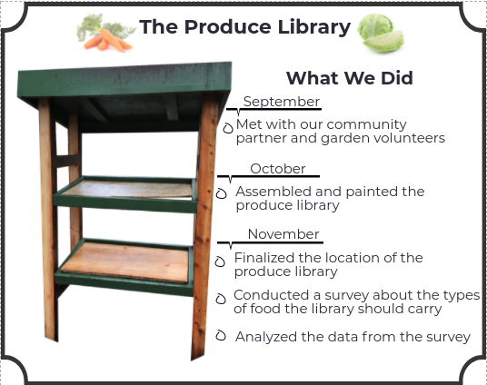
Figure 1. Completed produce library located at Riley Park Garden.

All of the people surveyed at Riley Park believed that the produce library will be a great addition to the community garden, and that community members would benefit from it. Refer to the appendix (Survey A-1) for this document. We surveyed people living in the community, volunteers at Riley Park, as well as possible donors from the farmer’s market. Once the produce library is operational and incorporated in Riley Park events and workshops, all respondents also believed that it would help improve food literacy. There was less of a consensus on whether the produce library would help to alleviate food insecurity in the community; 75% of respondents believed the produce library will be an effective way to alleviate local food insecurity. All respondents either agreed (1) or strongly agreed (3) that the community will benefit from the produce library. Our verbal questioning with the other volunteers was not recorded, and therefore we do not have formal documentation of this.
At this point in time, there are no results on the survey we created for Little Mountain Neighbourhood House. Please refer to the appendix (Survey A-2) for this survey.

Discussion
Since the produce library is not fully functioning, we cannot interpret the impacts it will have on the community. However, our surveys suggest that many people believe the library will help alleviate local food insecurity and that it would provide food literacy skills for all its users. The point of a garden is for its users to take not just the food, but also improve their health as well (Finley, 2013). The produce library, alone without any animations to improve food literacy, can provide temporary relief to those in need, but it is more of a bandaid solution to the larger issue. Animating the structure would help draw more people to the garden, where they could potentially become involved in the garden itself. Doing so helps make people become “more aware of issues of food security as well as their overall involvement with the food system” (Corrigan, 2011). In addition to drawing in more community members, the animations of the structure could provide information regarding food literacy. Improving food literacy leads to improving diets and overall health (Gallegos & Vidgen, 2010) . This would increase the health of those in the community ensuring that their quality of life is improved physically and mentally (Herbert, 2016).
In light of our results, our greatest limitation was time. We initially planned on building the produce library, animating it and using it to educate the community of sustainable food choices. However, making sure the library was structurally sound took more time than anticipated and it was neither animated nor functioning at the end of our project. In addition, our surveys had relatively small sample size of four and lack of data on people outside Riley Park community for the survey due to time limits. To improve our design, larger sample size will be taken in order to be more representative to the population. We will also design both qualitative and quantitative survey questions for produce library users to analyze the impact of the produce library to the community.

Conclusion
We successfully made a structurally sound produce library as part of our CBEL project. Although we did not get as far as we wanted in meeting our goals to animate and operate the produce library, the produce library contributes to community awareness of community food insecurity and food literacy. Our CBEL project that is in partnership with the Little Mountain Neighbourhood House, builds upon their mission of promoting diverse and culturally inclusive environments (Little Mountain Neighbourhood House, n.d.).
Moving onwards, we would first like to see work done on the produce library to bring more attention to it. We suggest painting the structure with words aligning with Riley Park values, and possibly by adding hanging baskets off the support posts. Secondly, we would like the produce library to become an integral and active part of Riley Park community workshops and events to help others learn about foods and cooking while being able to bring foods back home to cook with. We hope future LFS groups or members of the community can actively help to further enhance and improve the produce library.

References
Corrigan, M. P. (2011). Growing what you eat: Developing community gardens in
Baltimore,Maryland. Applied Geography, 31(4), 1232-1241. Retrieved from
https://doi.org/10.1016/j.apgeog.2011.01.017

Finley, R. (2013). A guerilla garderner in south central LA. [Video file]. Retrieved from
https://www.ted.com/talks/ron_finley_a_guerilla_gardener_in_south_central_la/transcript

Gallegos, D., & Vidgen, H.A. (2010). Food literacy: time for a new term or just another
buzzword?. Journal of the Home Economics Institute of Australia, 17(2), 2.

Hartwig, K. A., & Mason, M. (2016). Community Gardens for Refugee and Immigrant
Communities as a Means of Health Promotion. Journal of Community Health,
41(6), 1153-1159. Retrieved from
https://doi-org.ezproxy.library.ubc.ca/10.1007/s10900-016-0195-5Little Mountain

Neighbourhood House. (n.d.). Retrieved October 09, 2017, from
http://web.lmnhs.bc.ca/vision-mission-and-values/

Little Mountain Neighbourhood House. (n.d.).Community
Community Connection Programs for Newcomers. Retrieved by http://web.lmnhs.bc.ca/community/

Meiselman, Herbert L. “Quality of life, well-Being and wellness: Measuring subjective
health for foods and other products.” Food Quality and Preference, vol. 54, 2016, pp. 101–109., doi:10.1016/j.foodqual.2016.05.009.

Riley Park Community Garden. (n.d.). Garden & Shed. Retrieved from
https://www.rileyparkgarden.org/story/

Appendix

CBEL Critical Reflections
Student 1: Our CBEL project was an essential part in my understanding of the challenges that come along with trying to make change on a community level. Throughout lectures in LFS 350 and our time at Riley Park, my understanding of food justice changed quite a bit. I came into this course with the understanding that food justice is everyone’s right to food however, food justice also encompassess ideas of transforming our food system to fight for everyone's food choices and food accessibility as well as controlling and sharing our land. This hands-on experience in the community along with its challenges enabled me to come to the realization it takes communication, a community and more than three months to see sustainable change in the community. In retrospect, we may have been too ambitious with our initial goals for the span of three months. However, I learned what scope means in community based change and the importance of community engagement for community causes such as community gardens and food banks. Therefore, this experience is something I will carry with me as I have a sense of reference for future endeavours.

Student 2: Through LFS 350 community-based projects, I have a better understanding of how we could approach issues of food justice through asset-based community development. For this time, I did not work with external experts, but with citizens, but they are more enthusiastic to serve the community. At Riley Park, the community promotes food justice in the form of urban of community gardens. I have realized that community gardens are a good way to bring people together and to increase community awareness around food security issues. Food justice is not just a simple concept, but a complex, interrelated issue. At the beginning of the course, acknowledging and confronting historical, collective social trauma and persistent race, gender, and class inequalities is not easy for me to understand food justice. However, throughout the project, people around me at the community garden enable me to see individuals' and communities' ability to foster a just food system. There was meaningful engagement through dialogue and active listening between community members and I. Food justice is successfully approached by the community actions. The project also allows me to get a hands-on experience to address real life problems. I think that it is a very engaged learning experience for me to contribute my efforts to shape a socially just and sustainable food system in the community.

Student 3: Working on this CBEL project at Riley Park has allowed me to connect course concepts to problems faced in the community. Interestingly, my understanding of food justice has not changed; however, I do feel more aware of how food justice issues may impact a community. Food justice as a whole remains an intangible, complicated concept that I am unable to fully comprehend in my mind. I find it easier to approach when breaking the term down into its smaller parts. One of the principles of food justice is acknowledging race, class and gender inequalities. After some work in the community, I find I am able to better understand how race, class and gender inequities can continue to occur and be incredible obstacles in obtaining a more just food system. On the other hand, the CBEL project has also allowed me to understand that it is extremely difficult to change even a local food system. This is frustrating, but it has made me both more thoughtful and critical. I was able to write a paper on the whiteness of alternative food systems and how it excludes non-white and low income people, something I would not have been able to comment on before this course started. The process of working in the community and being able to connect it to the literature was interesting to me. Suddenly, I was much more curious about the studies conducted locally - I found master’s theses and literature on food systems in Vancouver. This helped to bring food justice issues closer, which aided in my understanding overall.

Student 4: This CBEL project has helped me understand what food justice might look like in an urban environment, as it has allowed me to see where community gardens fit into this concept. On a number of levels, they help promote food justice; one principle is that people have the right to grow their own food if they choose, and community gardens offer a space to make that possible. Similarly, they give people the opportunity to choose what they grow, which allows them to eat food that is both healthy and culturally appropriate. Finally, being able to grow one’s own food is both affordable and socially just.
However, while I was able to see how community gardens can promote food justice, it was also clear to me that they will not be enough to fulfill it everyone by themselves. The Riley Park Garden required the dedicated effort of numerous volunteers and a plot of land of a size that is not always available in an urban setting in order to produce food for a small group of people, relative to the overall size of the neighbourhood. Moreover, the food produced was only in quantities that would supplement a family’s normal produce consumption, so they would still require food from other sources. This made it clear how difficult it will be to achieve food justice globally, as the amount of space, time, and effort required to consistently feed people healthy food is staggering.

Student 5: As an LFS student, we are taught about the importance of a food security and the many aspects it emcompasses. Through the years, our knowledge has been built up through lectures; however, there are some things that cannot be taught in a classroom. In class we discussed various inequalities that would have been uncomfortable to discuss outside of the lecture environment, but it was difficult to really understand how this came into effect outside of the classroom. It was hard to fully grasp the concept of how and why people were being impacted by food insecurity. By working on the CBEL project at Riley Park, I now understand the importance of resolving food insecurity, specifically in the regards of race, class, and gender inequalities. I have learned that improvements are not instantaneous, but they take time and effort to build and develop. There are many steps that need to be taken in order for for us to resolve food insecurity and food justice. A large step towards this goal is by bringing awareness and understanding to the issues regarding inequalities and food insecurity.

Student 6: Even though I have a basic understanding of food justice from taking LFS courses in previous years, working on our CBEL in Riley Park has allowed me to have a different perspective towards the same social issue or concept. Before taking this course, I believed that local farms and small-scale family businesses are the most important components that make up the local food system. However, I now realize that community gardens also play an essential role in contributing to such food systems, such as educating individuals about the importance of self-reliance, promoting healthy dieting, as well as encouraging community engagement. Also, building and painting the produce library ourselves made me realize that maintaining a local food system requires a lot of effort and is much more consuming than I originally thought it would be. Since we have already spent a large amount of time on data collection and analysis, it is beyond my imagination how difficult it will be to work on large scale projects that promote healthy eating habits using sustainable methods. Through CBEL project, I have also learned that besides healthy eating, being able to access culturally appropriate food is also an important matter to everyone, especially to the minority groups in the neighborhood. I believe our produce library has the capability to increase the awareness of such issue, which can ultimately contribute to food security and food justice.

Survey A-1:
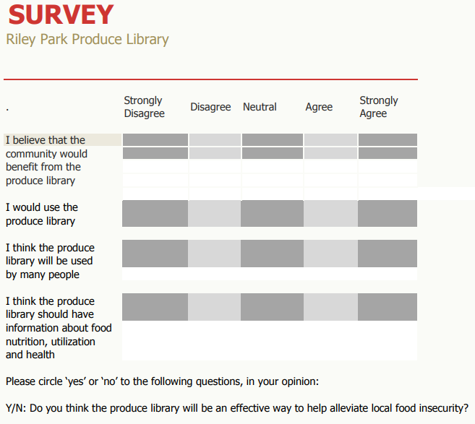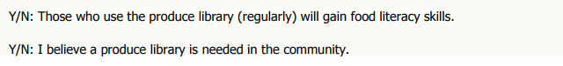

Survey A-2:

Survey:
Little Mountain Neighbourhood House + Riley Park Community Garden

1) Have you been to the Riley Park Community Garden? (Circle one)
YES | NO

- If Yes, what did you like about it? (Circle all that apply)
    - Free food at Garden Work Party (reword maybe?)
    - Having an inclusive space to connect with others in the community
    - Farmers Market
    - Garden Theatre/ Plays
    - All the above
    - None of the above (Write below your reasoning):

- If No, why have you not gone? (Circle all that apply)
i) I did not know about the garden.
ii) I do not know how to garden.
iii) Transportation issues.
iv) I am not interested in gardening.

2) Check each box that applies:
__ I am a refugee
__ I am from a family of immigrants
__ I am a single mother / father
__ I receive money from a government program

3) How often do you visit or participate in events at Riley Park? (Circle one)
Daily | Weekly | Monthly | Occasionally | Never

4) The Little Mountain Neighbourhood House has been beneficial to me/my family:
1. Strongly disagree  - never helpful | 2. Disagree  - rarely helpful | 3. Neutral  - sometimes  helpful | 4. Agree  - often helpful | 5. Strongly Agree  - very helpful

5) How did you hear about the Little Mountain Neighbourhood House? (Circle any that apply)

Friends/ Family | Online website | Brochure/ Flyer

Or specify below if through other forms:

6) I come to the Little Mountain Neighbourhood House because: (Circle all the apply)
- It provides me/my family with food.
- I like the community aspect in my life.
- Time with my family or friends.
- I can bring children.
- I can get helpful information.
- Other:___________________

7) Please circle your response:
- I am aware that using plant beds in Riley Park Garden is free
YES | NO

- I am aware that Riley Park Garden provides seeds for free
YES | NO

- I am aware that there are “Work Parties” each Saturday, where community members can help out in the garden and enjoy a free meal afterwards
YES | NO

8) Are there any suggestions that you would like to give us on how the garden can improve?

9) Anything else you would like to tell us?

